figs_tabs_results

#Geographical distribution of reference streamgauging stations ##Statistics for paper - Number of gauges in total:    
5615  
- Number of perennial gauges used in analysis (average number of years of data):  
4428(40.7131888)  
- Number of intermittent gauges taking in account only post-1800, mDur >= 1 (average number of years of data):  
1187(33.5846672)  
- Number of intermittent gauges taking in account only post-1800, mDur > 0 (average number of years of data):  
1546  
- Number of intermittent gauges taking in account only post-1800, mDur >= 30 (average number of years of data):  
880  
- Number of reaches in network:  
6198485  
- Average length of reaches in network:  
3.7518314  
- Total length of reaches in network:  
2.3255671^{7}  
- Total number of predictor variables:  
113  
- Total number of predictor variables kept in model for gauges < 10 m3/s:  
0  
- Total number of predictor variables kept in model for gauges >= 1 m3/s:  
0  
- Number of people living nearest to an IRES:

| predbasic800cat | popsum | popperc |
| --- | --- | --- |
| 1 | 4070671819 | 0.5150066 |
| 0 | 3833443489 | 0.4849934 |

## used (Mb) gc trigger (Mb) max used (Mb)  
## Ncells 4842740 258.7 8449634 451.3 8449634 451.3  
## Vcells 7668075 58.6 107301205 818.7 128844208 983.1

#Threshold sensitivity

## png   
## 2

## IRESperc threshold_u10 threshold_o10  
## 1: 0.4752991 0.45 0.45  
## 2: 0.3638072 0.55 0.45  
## 3: 0.4698649 0.45 0.55  
## 4: 0.3583730 0.55 0.55

#IRES extrapolation

## [1] "Number of climate-basins sub-units occurrences: "

## [1] 465

## [1] "For mdur >= 1, statistically extrapolating the prevalence of intermittence in rivers < 0.1 m3/s, we predict that 57% of rivers >= 0.01 m3/s are intermittent"

## [1] "For a total river length of 63956432.37 km"

## [1] "Example plots"

## Warning: Removed 1 row(s) containing missing values (geom_path).

## png   
## 2

## Warning: Removed 1 row(s) containing missing values (geom_path).

## png   
## 2

## Warning: Removed 9 row(s) containing missing values (geom_path).

## png   
## 2

## Warning: Removed 9 row(s) containing missing values (geom_path).

## png   
## 2

## [1] "For mdur >= 30, statistically extrapolating the prevalence of intermittence in rivers < 0.1 m3/s, we predict that 49% of rivers >= 0.01 m3/s are intermittent"

## used (Mb) gc trigger (Mb) max used (Mb)  
## Ncells 5427973 289.9 12158695 649.4 12158695 649.4  
## Vcells 250204780 1909.0 648174646 4945.2 600448944 4581.1

#Gauges map 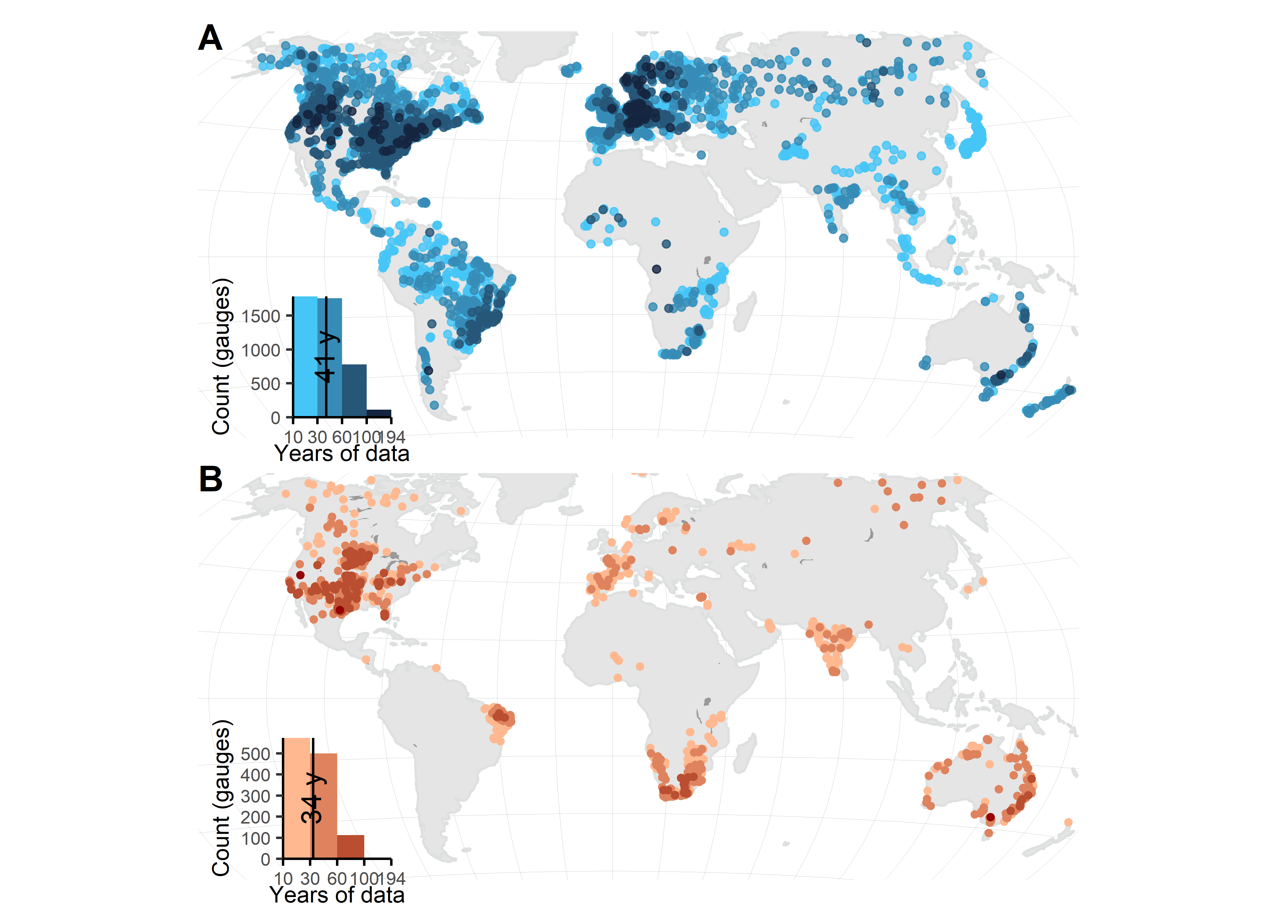

## used (Mb) gc trigger (Mb) max used (Mb)  
## Ncells 5903218 315.3 12158695 649.4 12158695 649.4  
## Vcells 274939268 2097.7 648174646 4945.2 600448944 4581.1

#WaterGAP stats

| bin | bin_lformat | pearsonr | mae | smape | rsq | rsq_nooutliers | n_total | noutliers | comp |
| --- | --- | --- | --- | --- | --- | --- | --- | --- | --- |
| 1 | 0.01-1 | 0.375 | 0.61 | 0.75 | 0.141 | 0.141 | 192 | 0 | qmean_dism3pyr |
| 2 | 1-9.94 | 0.486 | 2.27 | 0.44 | 0.236 | 0.259 | 540 | 1 | qmean_dism3pyr |
| 3 | 10.06-99.81 | 0.848 | 8.87 | 0.24 | 0.719 | 0.754 | 848 | 3 | qmean_dism3pyr |
| 4 | 101.06-959.93 | 0.958 | 33.52 | 0.12 | 0.918 | 0.950 | 424 | 3 | qmean_dism3pyr |
| 5 | 1016.03-9527.08 | 0.993 | 141.80 | 0.05 | 0.986 | 0.992 | 109 | 2 | qmean_dism3pyr |
| 6 | 10057.38-181046.42 | 0.999 | 1511.61 | 0.05 | 0.998 | 0.999 | 18 | 1 | qmean_dism3pyr |
| 7 | all | 0.999 | 30.85 | 0.30 | 0.958 | 0.960 | 2131 | 3 | qmean_dism3pyr |
| 1 | 0.01-1 | 0.169 | 0.24 | NaN | 0.029 | 0.029 | 192 | 0 | q90_dism3mn |
| 2 | 1-9.94 | 0.340 | 1.32 | NaN | 0.116 | 0.121 | 540 | 3 | q90_dism3mn |
| 3 | 10.06-99.81 | 0.496 | 9.52 | 0.83 | 0.246 | 0.247 | 848 | 3 | q90_dism3mn |
| 4 | 101.06-959.93 | 0.657 | 63.76 | 0.60 | 0.431 | 0.480 | 424 | 2 | q90_dism3mn |
| 5 | 1016.03-9527.08 | 0.918 | 419.88 | 0.44 | 0.842 | 0.811 | 109 | 1 | q90_dism3mn |
| 6 | 10057.38-181046.42 | 0.997 | 3131.90 | 0.25 | 0.993 | 0.993 | 18 | 2 | q90_dism3mn |
| 7 | all | 0.996 | 64.76 | NaN | 0.844 | 0.845 | 2131 | 1 | q90_dism3mn |

## used (Mb) gc trigger (Mb) max used (Mb)  
## Ncells 5866340 313.3 12158695 649.4 12158695 649.4  
## Vcells 275024534 2098.3 648174646 4945.2 600448944 4581.1

#Environmental distribution of reference streamgauging stations 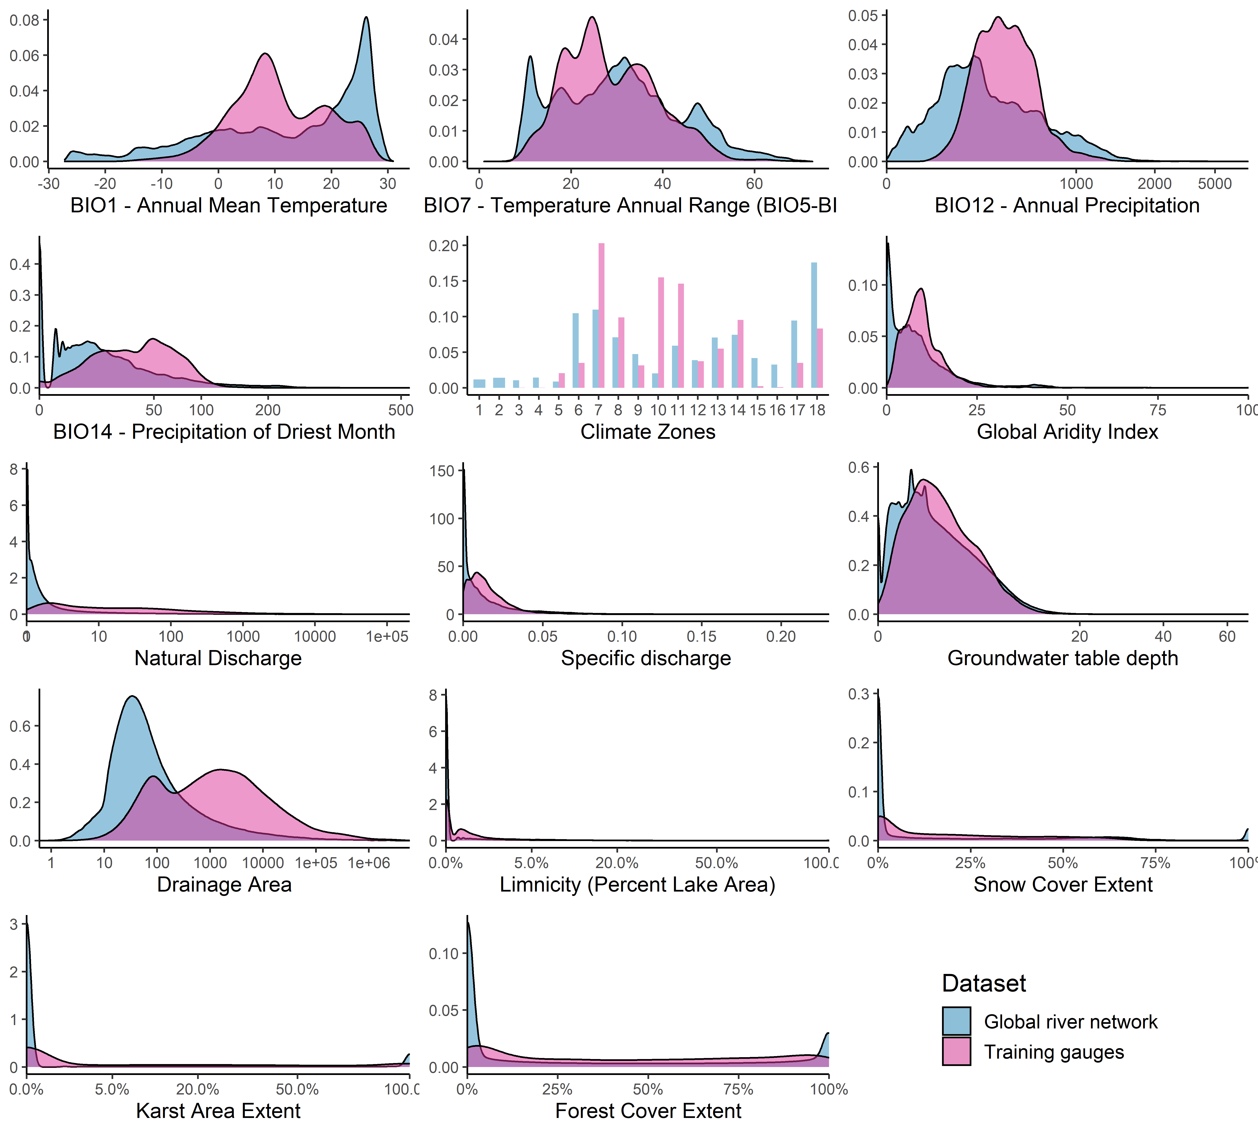

## png   
## 2

## used (Mb) gc trigger (Mb) max used (Mb)  
## Ncells 6103809 326.0 12158695 649.4 12158695 649.4  
## Vcells 275554143 2102.4 648174646 4945.2 600448944 4581.1

#Methods - Table 2. Specification and benchmark comparison of models

## [1] "Setup table u10"

| selection | type | learner_format | inner_folds | inner_n_evals | alpha | mtry | minnodesize | fraction | minor_weight|ratio | npredictors | outer_repeats | outer_folds |
| --- | --- | --- | --- | --- | --- | --- | --- | --- | --- | --- | --- | --- |
| Algorithm | Classif. | default RF | 4 | 100 |  | 11-56 | 1-10 | 0.2-0.8 | NA | 113 | 2 | 3 |
| Algorithm | Classif. | CIF | NA | NA | 0.05 | 11 |  | 0.632 | NA | 113 | 2 | 3 |
| Algorithm | Classif. | default RF-oversampled | 4 | 100 |  | 11-56 | 1-10 | 0.2-0.8 | 1.982162 | 113 | 2 | 3 |
| Algorithm | Classif. | CIF-oversampled | NA | NA | 0.05 | 11 |  | 0.632 | 1.982162 | 113 | 2 | 3 |
| Algorithm | Classif. | default RF-weighted classes | 4 | 100 |  | 11-56 | 1-10 | 0.2-0.8 | 1.982162 | 113 | 2 | 3 |
| Algorithm | Classif. | CIF-weighted classes | NA | NA | 0.05 | 11 |  | 0.632 | 1.982162 | 113 | 2 | 3 |
| Algorithm | Regr. |  | 4 | 100 |  | 11-56 | 10 |  | NA | 113 | 2 | 3 |
| Predictors | Classif. |  | 4 | 100 |  | 9-46 | 1-10 |  | 1.982162 | 113 | 1 | 40 |

## [1] "Results table u10"

| selection | learner_format | resampling_id | outer_repeats | outer_folds | time_train | time_predict | bacc | threshold_class | spe | sen | pre | bbrier | auc |
| --- | --- | --- | --- | --- | --- | --- | --- | --- | --- | --- | --- | --- | --- |
| Algorithm | default RF | repeated_cv | 2 | 3 | 0 | 0 | 0.875 | 0.5 | 0.944 | 0.807 | 0.878 | 0.078 | 0.875 |
| Algorithm | CIF | repeated_cv | 2 | 3 | 0 | 0 | 0.868 | 0.5 | 0.944 | 0.791 | 0.878 | 0.079 | 0.868 |
| Algorithm | default RF-oversampled | repeated_cv | 2 | 3 | 0 | 0 | 0.884 | 0.5 | 0.925 | 0.843 | 0.849 | 0.077 | 0.884 |
| Algorithm | CIF-oversampled | repeated_cv | 2 | 3 | 0 | 0 | 0.881 | 0.5 | 0.912 | 0.849 | 0.830 | 0.080 | 0.881 |
| Algorithm | default RF-weighted classes | repeated_cv | 2 | 3 | 0 | 0 | 0.880 | 0.5 | 0.921 | 0.840 | 0.842 | 0.080 | 0.880 |
| Algorithm | CIF-weighted classes | repeated_cv | 2 | 3 | 0 | 0 | 0.875 | 0.5 | 0.922 | 0.828 | 0.842 | 0.080 | 0.875 |
| Algorithm |  | repeated_cv | 2 | 3 | 0 | 0 | 0.861 | 0.5 | 0.941 | 0.781 | 0.870 | 0.084 | 0.947 |
| Algorithm |  | repeated_cv | 2 | 3 | 0 | 0 | 0.859 | 0.5 | 0.940 | 0.778 | 0.867 | 0.084 | 0.946 |
| Predictors |  | repeated_cv | 1 | 40 | 0 | 0 | 0.879 | 0.5 | 0.913 | 0.845 | 0.830 | 0.081 | 0.879 |
| Predictors |  | repeated_cv | 2 | 3 | 0 | 0 | 0.884 | 0.5 | 0.919 | 0.848 | 0.841 | 0.078 | 0.884 |
| Predictors |  | repeated-spcv-coords | 1 | 40 | 0 | 0 | 0.846 | 0.5 | 0.884 | 0.809 | 0.778 | 0.102 | 0.846 |

## [1] "Setup table o1"

| selection | type | learner_format | inner_folds | inner_n_evals | alpha | mtry | minnodesize | fraction | minor_weight|ratio | npredictors | outer_repeats | outer_folds |
| --- | --- | --- | --- | --- | --- | --- | --- | --- | --- | --- | --- | --- |
| Algorithm | Classif. | default RF | 4 | 100 |  | 11-56 | 1-10 | 0.2-0.8 | NA | 113 | 2 | 3 |
| Algorithm | Classif. | CIF | NA | NA | 0.05 | 11 |  | 0.632 | NA | 113 | 2 | 3 |
| Algorithm | Classif. | default RF-oversampled | 4 | 100 |  | 11-56 | 1-10 | 0.2-0.8 | 4.870277 | 113 | 2 | 3 |
| Algorithm | Classif. | CIF-oversampled | NA | NA | 0.05 | 11 |  | 0.632 | 4.870277 | 113 | 2 | 3 |
| Algorithm | Classif. | default RF-weighted classes | 4 | 100 |  | 11-56 | 1-10 | 0.2-0.8 | 4.870277 | 113 | 2 | 3 |
| Algorithm | Classif. | CIF-weighted classes | NA | NA | 0.05 | 11 |  | 0.632 | 4.870277 | 113 | 2 | 3 |
| Algorithm | Regr. |  | 4 | 100 |  | 11-56 | 10 |  | NA | 113 | 2 | 3 |
| Predictors | Classif. |  | 4 | 100 |  | 8-41 | 1-10 |  | 4.870277 | 113 | 2 | 3 |

## [1] "Results table o1"

| selection | learner_format | resampling_id | outer_repeats | outer_folds | time_train | time_predict | bacc | threshold_class | spe | sen | pre | bbrier | auc |
| --- | --- | --- | --- | --- | --- | --- | --- | --- | --- | --- | --- | --- | --- |
| Algorithm | default RF | repeated_cv | 2 | 3 | 0 | 0 | 0.870 | 0.5 | 0.978 | 0.761 | 0.878 | 0.047 | 0.869 |
| Algorithm | CIF | repeated_cv | 2 | 3 | 0 | 0 | 0.835 | 0.5 | 0.982 | 0.688 | 0.887 | 0.053 | 0.835 |
| Algorithm | default RF-oversampled | repeated_cv | 2 | 3 | 0 | 0 | 0.911 | 0.5 | 0.941 | 0.881 | 0.753 | 0.057 | 0.911 |
| Algorithm | CIF-oversampled | repeated_cv | 2 | 3 | 0 | 0 | 0.900 | 0.5 | 0.954 | 0.845 | 0.790 | 0.054 | 0.900 |
| Algorithm | default RF-weighted classes | repeated_cv | 2 | 3 | 0 | 0 | 0.909 | 0.5 | 0.936 | 0.881 | 0.739 | 0.060 | 0.909 |
| Algorithm | CIF-weighted classes | repeated_cv | 2 | 3 | 0 | 0 | 0.875 | 0.5 | 0.967 | 0.782 | 0.830 | 0.052 | 0.875 |
| Algorithm |  | repeated_cv | 2 | 3 | 0 | 0 | 0.834 | 0.5 | 0.980 | 0.687 | 0.878 | 0.053 | 0.960 |
| Algorithm |  | repeated_cv | 2 | 3 | 0 | 0 | 0.838 | 0.5 | 0.980 | 0.695 | 0.879 | 0.053 | 0.960 |
| Predictors |  | repeated_cv | 2 | 3 | 0 | 0 | 0.909 | 0.5 | 0.940 | 0.878 | 0.751 | 0.056 | 0.909 |
| Predictors |  | repeated_cv | 1 | 40 | 0 | 0 | 0.912 | 0.5 | 0.936 | 0.888 | 0.741 | 0.059 | 0.912 |
| Predictors |  | repeated-spcv-coords | 2 | 3 | 0 | 0 | 0.858 | 0.5 | 0.932 | 0.785 | 0.704 | 0.073 | 0.858 |

## used (Mb) gc trigger (Mb) max used (Mb)  
## Ncells 5871236 313.6 12158695 649.4 12158695 649.4  
## Vcells 275272605 2100.2 648174646 4945.2 600448944 4581.1

#Methods - Figure 2. Benchmark comparison of models through curves

#Main text - Figure 2. Variable importance for top 20 variables

## Coordinate system already present. Adding new coordinate system, which will replace the existing one.

## Scale for 'x' is already present. Adding another scale for 'x', which will  
## replace the existing scale.

## Scale for 'y' is already present. Adding another scale for 'y', which will  
## replace the existing scale.

## png   
## 2

## used (Mb) gc trigger (Mb) max used (Mb)  
## Ncells 245601383 13116.6 525768691 28079.1 248420761 13267.1  
## Vcells 306887361 2341.4 648174646 4945.2 600448944 4581.1

#Main text - Figure 3. Partial dependence plots 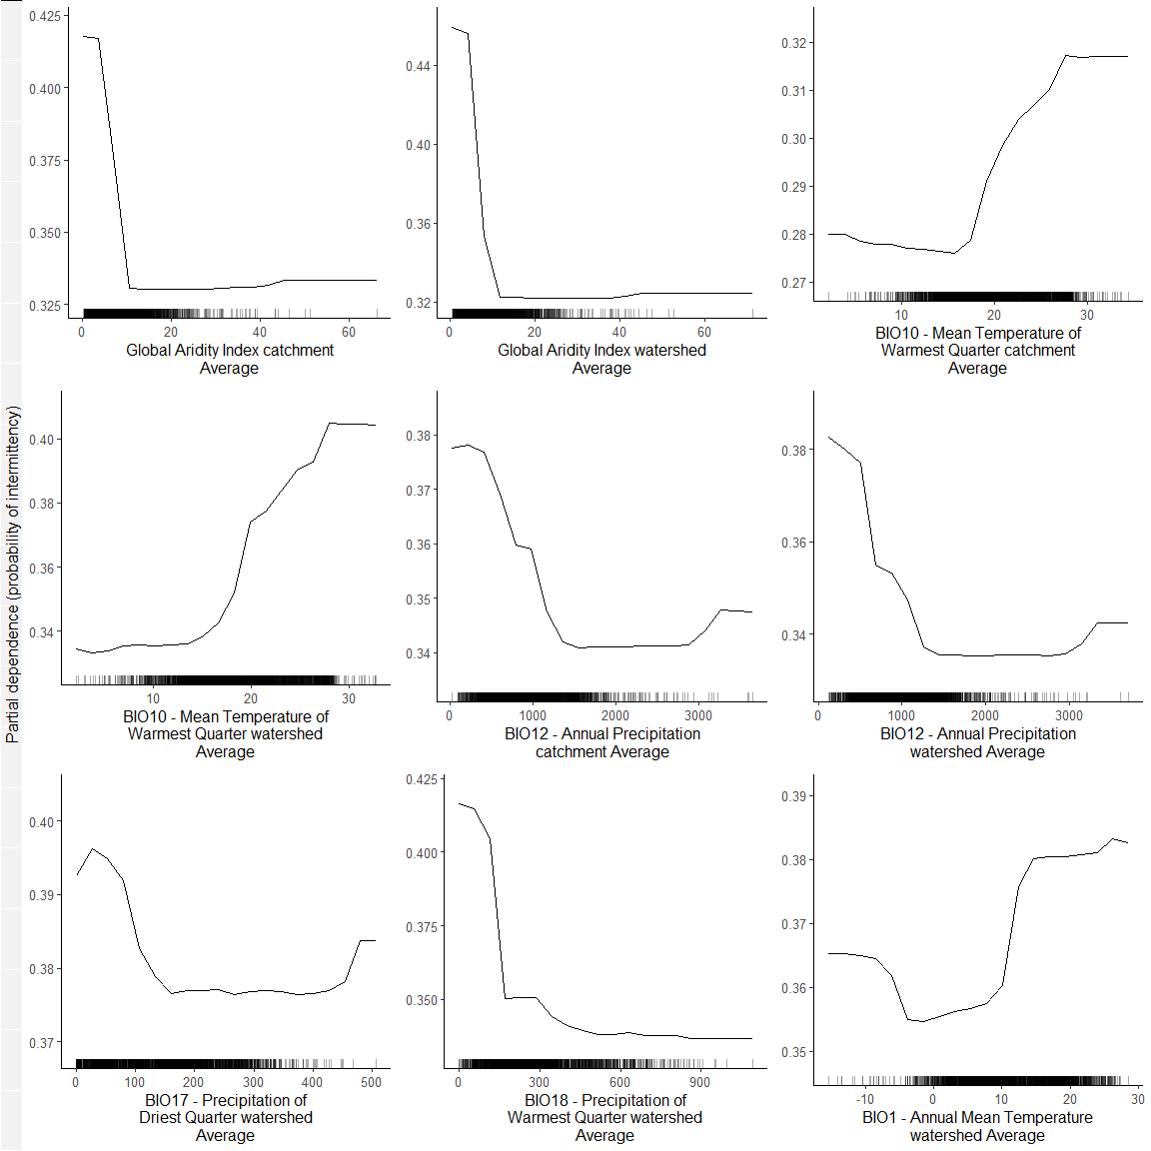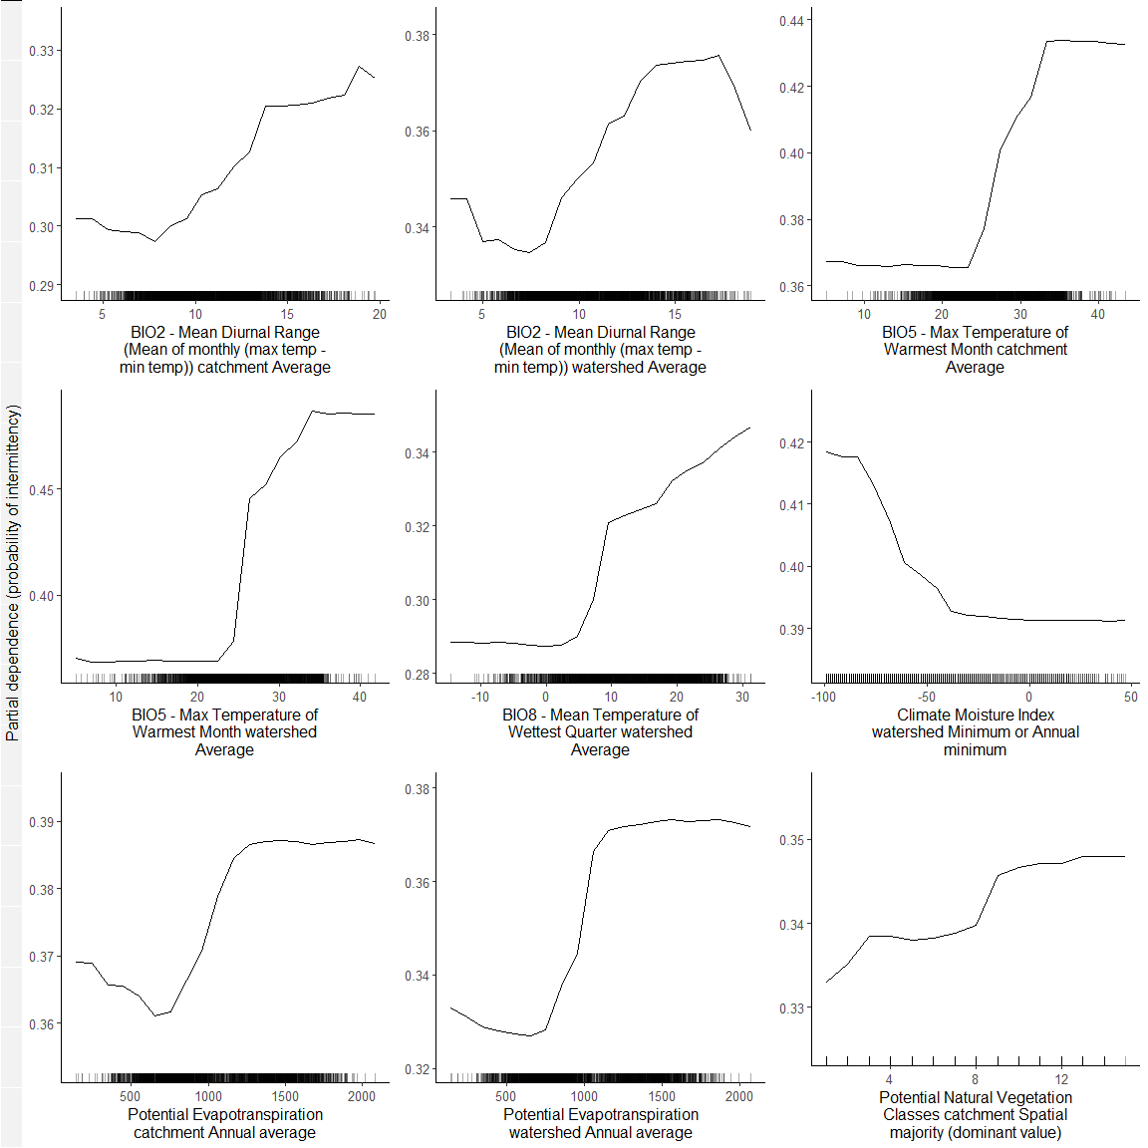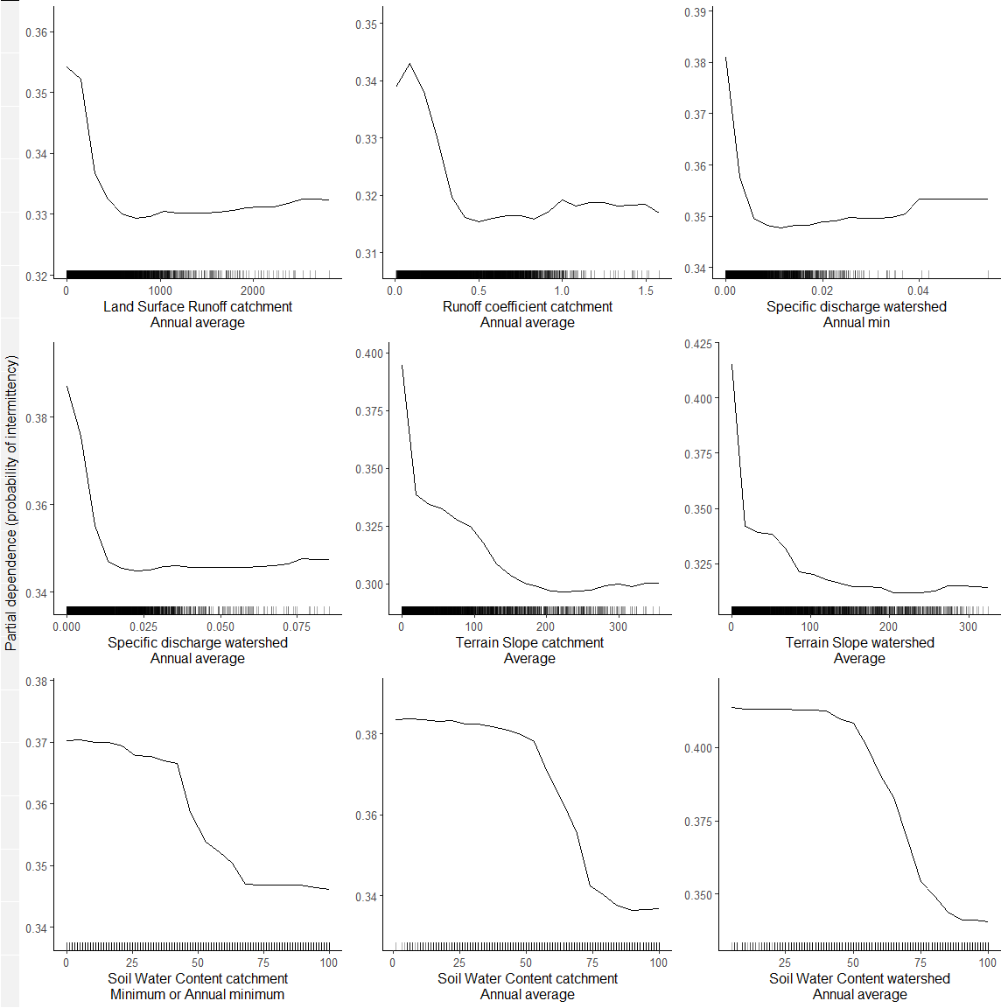

## [[1]]  
## NULL  
##   
## [[2]]  
## NULL  
##   
## [[3]]  
## NULL

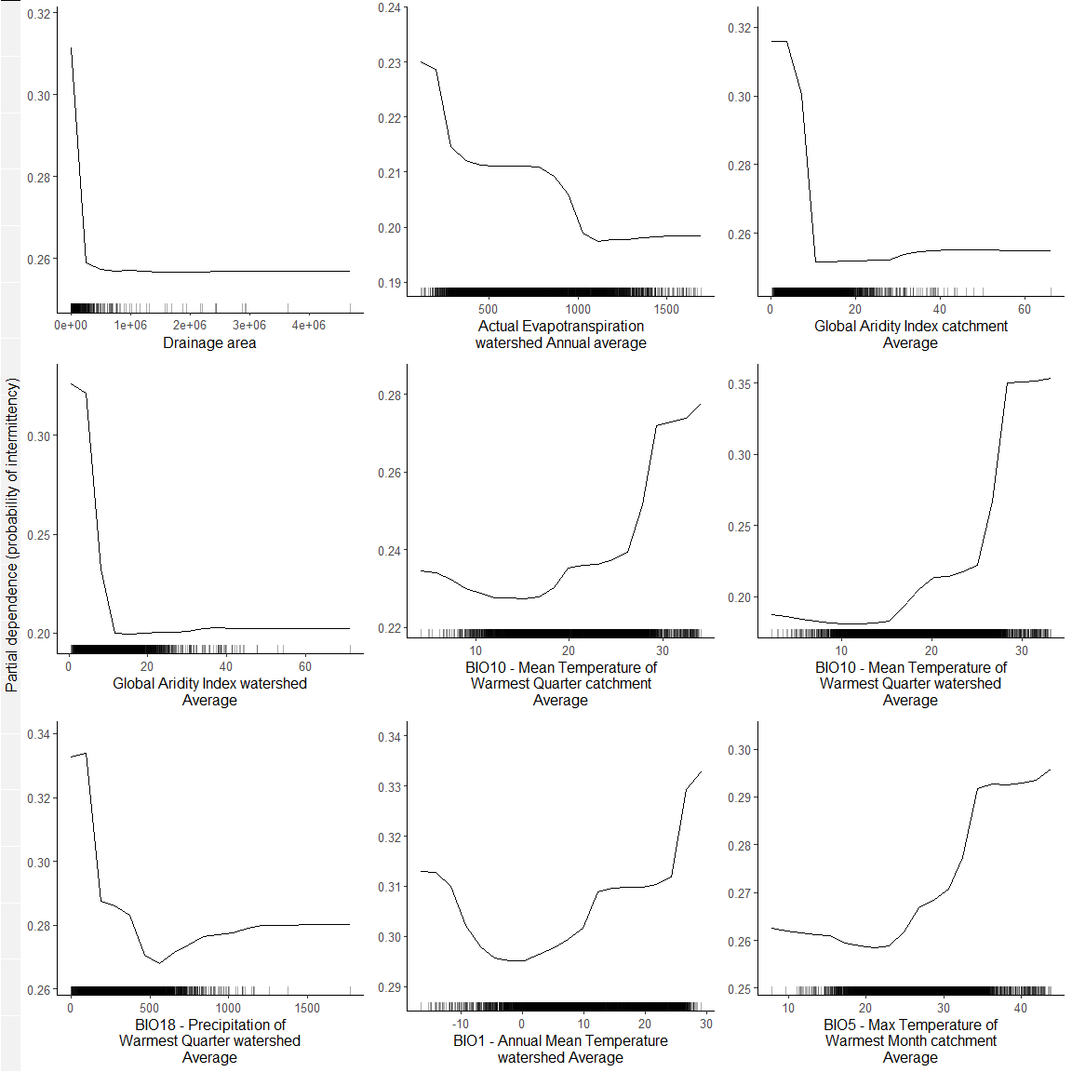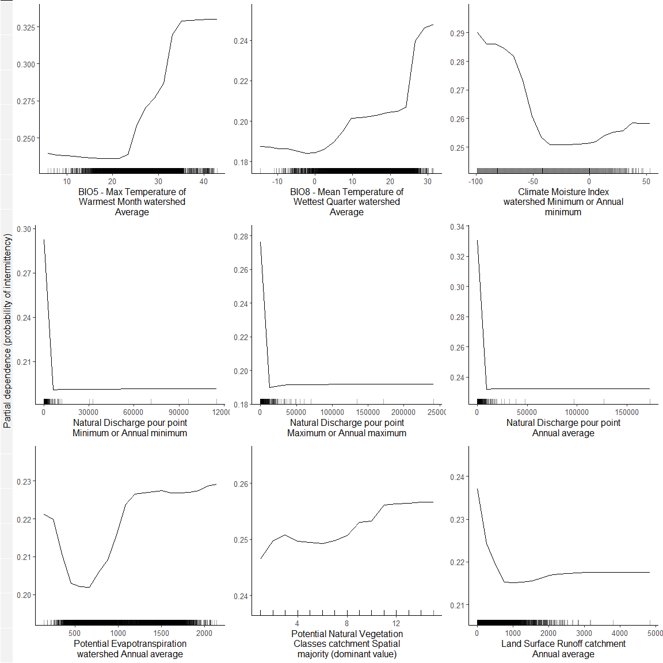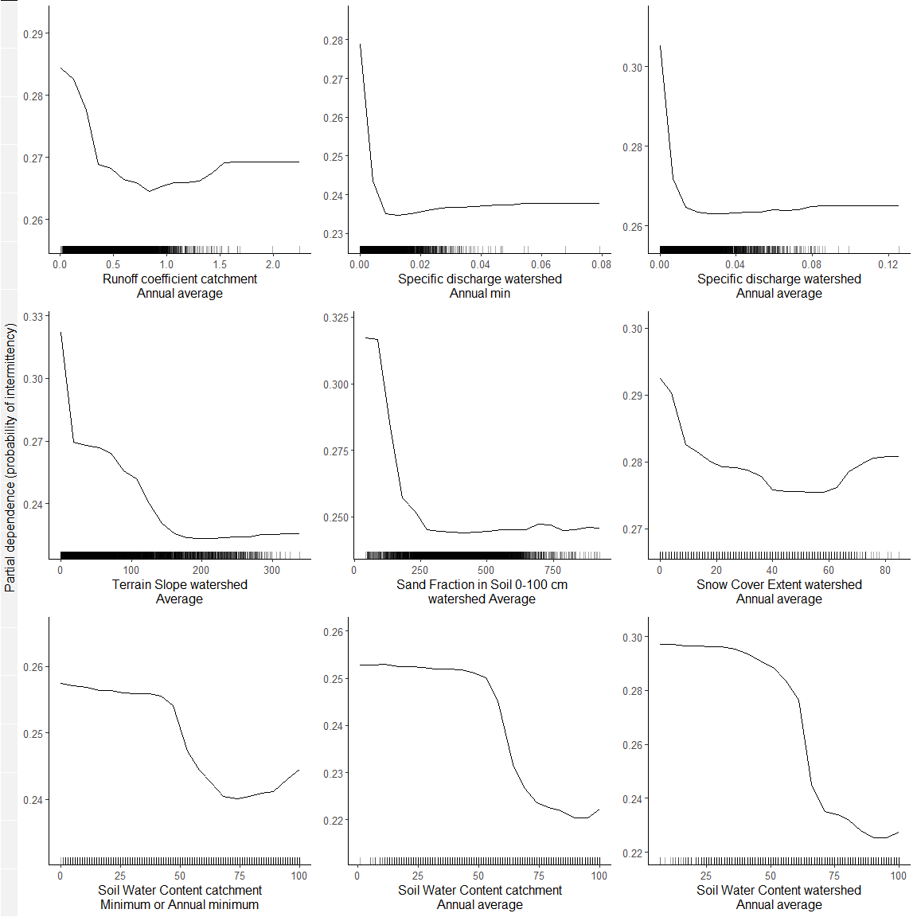

## [[1]]  
## NULL  
##   
## [[2]]  
## NULL  
##   
## [[3]]  
## NULL

## used (Mb) gc trigger (Mb) max used (Mb)  
## Ncells 246488446 13164.0 525768691 28079.1 254741914 13604.7  
## Vcells 313534198 2392.1 648174646 4945.2 600448944 4581.1

#Methods - Figure 3 A. Predictions uncertainty by metavariable and environment 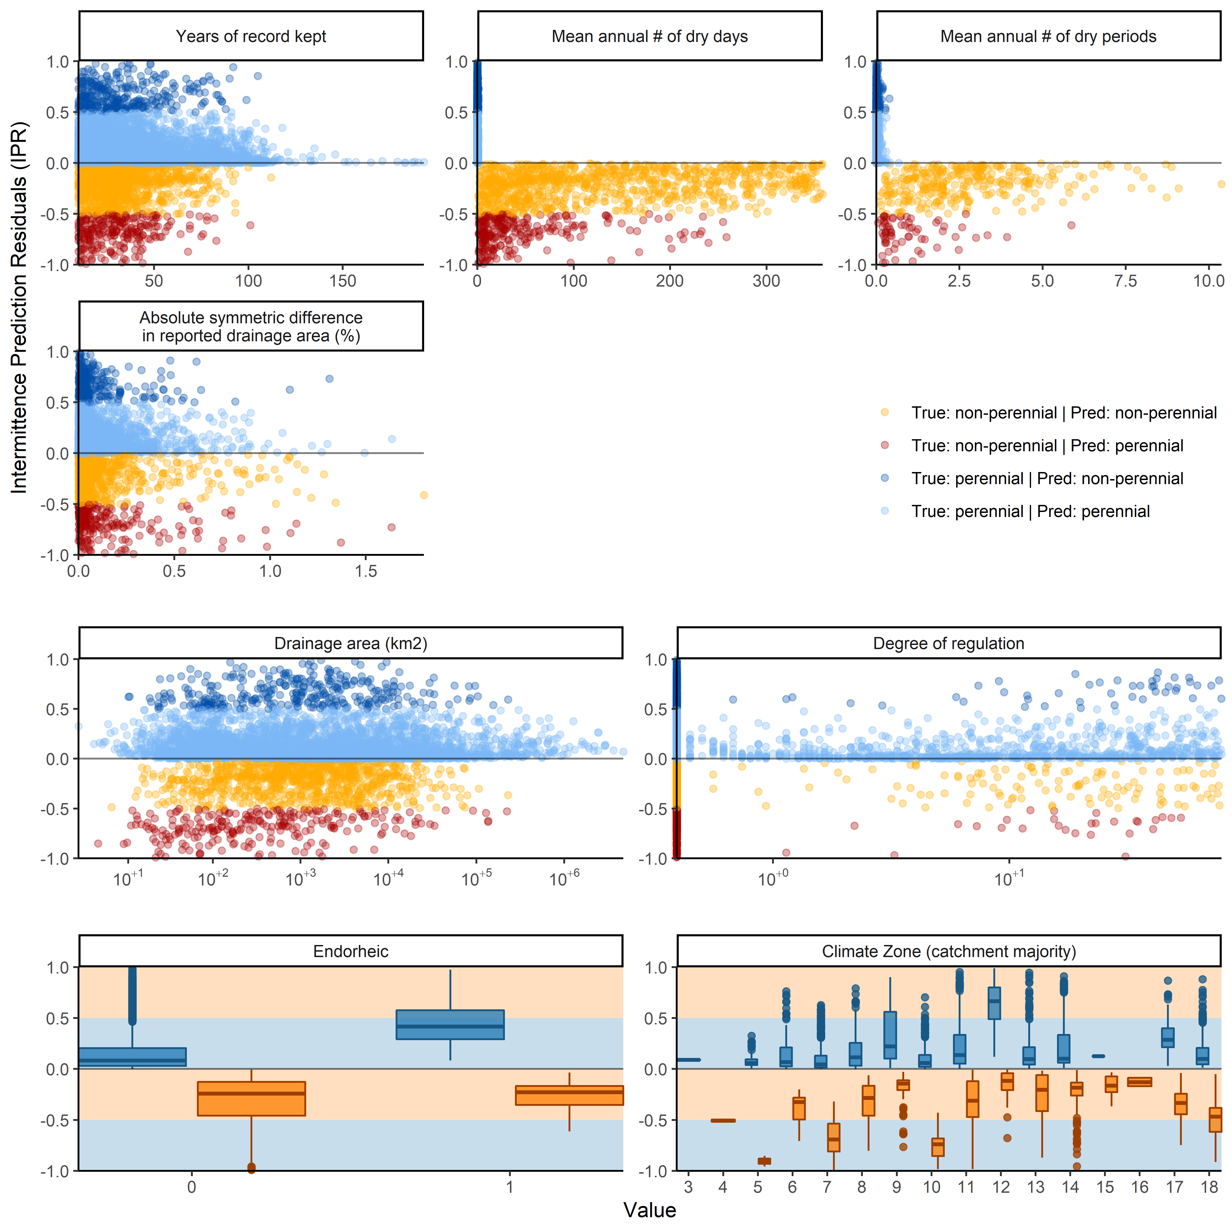

## used (Mb) gc trigger (Mb) max used (Mb)  
## Ncells 245736058 13123.8 525768691 28079.1 256484917 13697.8  
## Vcells 307612457 2346.9 648174646 4945.2 600448944 4581.1

#Final binned summary statistics for split model approach(< 10 and >= 1)

## [1] "Split model approach: 3-fold non-spatial CV"

## [1] "Overal bacc:0.9"

| bin | paste0 | inter_confu | pere_confu | misclas | sens | spec | N | predtrue_inter |
| --- | --- | --- | --- | --- | --- | --- | --- | --- |
| 1 | 0-0.1 | 42|4 | 7|6 | 0.19 | 0.91 | 0.46 | 59 | 83|78 |
| 2 | 0.1-1 | 292|55 | 44|504 | 0.11 | 0.84 | 0.92 | 895 | 38|39 |
| 3 | 1-9.94 | 490|70 | 111|1217 | 0.10 | 0.88 | 0.92 | 1888 | 32|30 |
| 4 | 10.01-99.86 | 175|24 | 82|1459 | 0.06 | 0.88 | 0.95 | 1740 | 15|11 |
| 5 | 100.05-989.32 | 33|1 | 24|757 | 0.03 | 0.97 | 0.97 | 815 | 7|4 |
| 6 | 1004.09-9514.03 | 1|0 | 2|187 | 0.01 | 1.00 | 0.99 | 190 | 2|1 |
| 7 | 10060.39-173274.11 | 0|0 | 0|28 | 0.00 | NaN | 1.00 | 28 | 0|0 |
| NA | All | 1033|154 | 270|4158 | 0.08 | 0.87 | 0.94 | 5615 | 23|21 |

## [1] "Slit model approach: 40-fold spatial CV"

## [1] "Overal bacc:0.86"

| bin | paste0 | inter_confu | pere_confu | misclas | sens | spec | N | predtrue_inter |
| --- | --- | --- | --- | --- | --- | --- | --- | --- |
| 1 | 0-0.1 | 43|3 | 9|4 | 0.20 | 0.93 | 0.31 | 59 | 88|78 |
| 2 | 0.1-1 | 280|67 | 54|494 | 0.14 | 0.81 | 0.90 | 895 | 37|39 |
| 3 | 1-9.94 | 459|101 | 151|1177 | 0.13 | 0.82 | 0.89 | 1888 | 32|30 |
| 4 | 10.01-99.86 | 143|56 | 87|1454 | 0.08 | 0.72 | 0.94 | 1740 | 13|11 |
| 5 | 100.05-989.32 | 14|20 | 16|765 | 0.04 | 0.41 | 0.98 | 815 | 4|4 |
| 6 | 1004.09-9514.03 | 0|1 | 0|189 | 0.01 | 0.00 | 1.00 | 190 | 0|1 |
| 7 | 10060.39-173274.11 | 0|0 | 0|28 | 0.00 | NaN | 1.00 | 28 | 0|0 |
| NA | All | 939|248 | 317|4111 | 0.10 | 0.79 | 0.93 | 5615 | 22|21 |

#Binned summary statistics for single model approach

## [1] "Single model approach: 3-fold non-<U+2663>spatial CV"

| bin | paste0 | inter_confu | pere_confu | misclas | sens | spec | N | predtrue_inter |
| --- | --- | --- | --- | --- | --- | --- | --- | --- |
| 1 | 0-0.1 | 42|4 | 9|4 | 0.22 | 0.91 | 0.31 | 59 | 86|78 |
| 2 | 0.1-1 | 303|44 | 64|484 | 0.12 | 0.87 | 0.88 | 895 | 41|39 |
| 3 | 1-9.94 | 498|62 | 123|1205 | 0.10 | 0.89 | 0.91 | 1888 | 33|30 |
| 4 | 10.01-99.86 | 166|33 | 62|1479 | 0.05 | 0.83 | 0.96 | 1740 | 13|11 |
| 5 | 100.05-989.32 | 30|4 | 20|761 | 0.03 | 0.88 | 0.97 | 815 | 6|4 |
| 6 | 1004.09-9514.03 | 1|0 | 1|188 | 0.01 | 1.00 | 0.99 | 190 | 1|1 |
| 7 | 10060.39-173274.11 | 0|0 | 0|28 | 0.00 | NaN | 1.00 | 28 | 0|0 |
| NA | All | 1040|147 | 279|4149 | 0.08 | 0.88 | 0.94 | 5615 | 23|21 |

## used (Mb) gc trigger (Mb) max used (Mb)  
## Ncells 245644287 13118.9 525768691 28079.1 356151104 19020.6  
## Vcells 310585343 2369.6 648174646 4945.2 600448944 4581.1

#Basin-level accuracy and bias plots

## png   
## 2

## png   
## 2

## used (Mb) gc trigger (Mb) max used (Mb)  
## Ncells 246045566 13140.3 525768691 28079.1 356151104 19020.6  
## Vcells 408570222 3117.2 648174646 4945.2 600448944 4581.1

#Comparison of results with regional-national estimates

## Warning in if (!expand) {: the condition has length > 1 and only the first  
## element will be used  
  
## Warning in if (!expand) {: the condition has length > 1 and only the first  
## element will be used

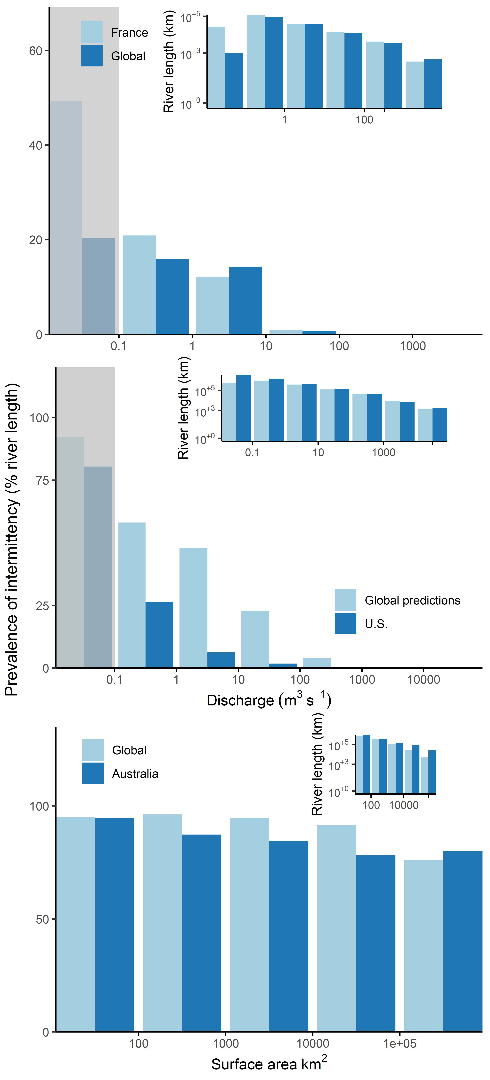

## [1] "Data for comparison: US - all"

| bin | perc | binsumlength | dat | binformat |
| --- | --- | --- | --- | --- |
| 1 | 80.4042871 | 3274335.902 | U.S. | 0 - 0.1 |
| 1 | 92.0983331 | 573703.000 | Global predictions | 0 - 0.1 |
| 2 | 26.4190528 | 1214114.253 | U.S. | 0.1 - 0 |
| 2 | 58.0998359 | 909102.430 | Global predictions | 0.1 - 0 |
| 3 | 6.3820353 | 410379.134 | U.S. | 1 - 9 |
| 3 | 47.7891864 | 368646.180 | Global predictions | 1 - 9 |
| 4 | 1.7990943 | 138635.649 | U.S. | 10 - 99 |
| 4 | 22.8155168 | 122846.790 | Global predictions | 10 - 99 |
| 5 | 0.1221212 | 42704.306 | U.S. | 100 - 999 |
| 5 | 3.9444863 | 40914.580 | Global predictions | 100 - 999 |
| 6 | 0.0000000 | 7386.525 | U.S. | 1000 - 9999 |
| 6 | 0.0000000 | 8403.250 | Global predictions | 1000 - 9999 |
| 7 | 0.0000000 | 1731.468 | U.S. | 10000 - 99999 |
| 7 | 0.0000000 | 1586.010 | Global predictions | 10000 - 99999 |
| world | 19.2564041 | NA | U.S. |  |
| world | 50.5685439 | NA | Global predictions |  |

## [1] "Data for comparison: US - no artificial"

| bin | perc | binsumlength | dat | binformat |
| --- | --- | --- | --- | --- |
| 1 | 82.240735 | 3201219.490 | U.S. | 0 - 0.1 |
| 1 | 92.098333 | 573703.000 | Global predictions | 0 - 0.1 |
| 2 | 27.822790 | 1152858.814 | U.S. | 0.1 - 0 |
| 2 | 58.099836 | 909102.430 | Global predictions | 0.1 - 0 |
| 3 | 7.055831 | 371190.051 | U.S. | 1 - 9 |
| 3 | 47.789186 | 368646.180 | Global predictions | 1 - 9 |
| 4 | 2.920497 | 85402.796 | U.S. | 10 - 99 |
| 4 | 22.815517 | 122846.790 | Global predictions | 10 - 99 |
| 5 | 2.213067 | 2356.503 | U.S. | 100 - 999 |
| 5 | 3.944486 | 40914.580 | Global predictions | 100 - 999 |
| 6 | 0.000000 | 8.797 | U.S. | 1000 - 9999 |
| 6 | 0.000000 | 8403.250 | Global predictions | 1000 - 9999 |
| 7 | 0.000000 | 1586.010 | Global predictions | 10000 - 99999 |
| world | 21.683254 | NA | U.S. |  |
| world | 50.568544 | NA | Global predictions |  |

## [1] "Data for comparison: France"

| bin | perc | binsumlength | dat | binformat |
| --- | --- | --- | --- | --- |
| 1 | 49.3456187 | 24671.396 | France | 0 - 0.1 |
| 1 | 20.2756265 | 1041.990 | Global | 0 - 0.1 |
| 2 | 20.8665522 | 117633.818 | France | 0.1 - 0 |
| 2 | 15.8709918 | 86413.440 | Global | 0.1 - 0 |
| 3 | 12.1569737 | 36726.994 | France | 1 - 9 |
| 3 | 14.2369047 | 38964.860 | Global | 1 - 9 |
| 4 | 0.8252554 | 13859.588 | France | 10 - 99 |
| 4 | 0.6079502 | 12685.250 | Global | 10 - 99 |
| 5 | 0.0000000 | 4165.854 | France | 100 - 999 |
| 5 | 0.0000000 | 3674.000 | Global | 100 - 999 |
| 6 | 0.0000000 | 346.957 | France | 1000 - 9999 |
| 6 | 0.0000000 | 472.340 | Global | 1000 - 9999 |
| world | 16.8614882 | NA | France |  |
| world | 13.5990401 | NA | Global |  |

## [1] "Data for comparison: Australia"

| bin | perc | binsumlength | dat | binformat |
| --- | --- | --- | --- | --- |
| 1 | 94.70478 | 940831.36 | Australia | 10 - 100 |
| 1 | 94.99147 | 779660.03 | Global | 10 - 100 |
| 2 | 87.30249 | 340980.24 | Australia | 100 - 999 |
| 2 | 96.22667 | 353102.77 | Global | 100 - 999 |
| 3 | 84.52900 | 142922.98 | Australia | 1000 - 9999 |
| 3 | 94.53028 | 101227.93 | Global | 1000 - 9999 |
| 4 | 78.27274 | 95357.03 | Australia | 10000 - 99999 |
| 4 | 91.57236 | 29489.50 | Global | 10000 - 99999 |
| 5 | 79.93368 | 29177.03 | Australia | 1e+05 - 999999 |
| 5 | 75.89412 | 5491.69 | Global | 1e+05 - 999999 |
| world | 90.84730 | NA | Australia |  |
| world | 95.13628 | NA | Global |  |

## Warning in remove(ft_plot): object 'ft_plot' not found

## used (Mb) gc trigger (Mb) max used (Mb)  
## Ncells 247695692 13228.4 525768691 28079.1 356151104 19020.6  
## Vcells 527464752 4024.3 1367012968 10429.5 1265455587 9654.7

## Warning in if (!expand) {: the condition has length > 1 and only the first  
## element will be used  
  
## Warning in if (!expand) {: the condition has length > 1 and only the first  
## element will be used

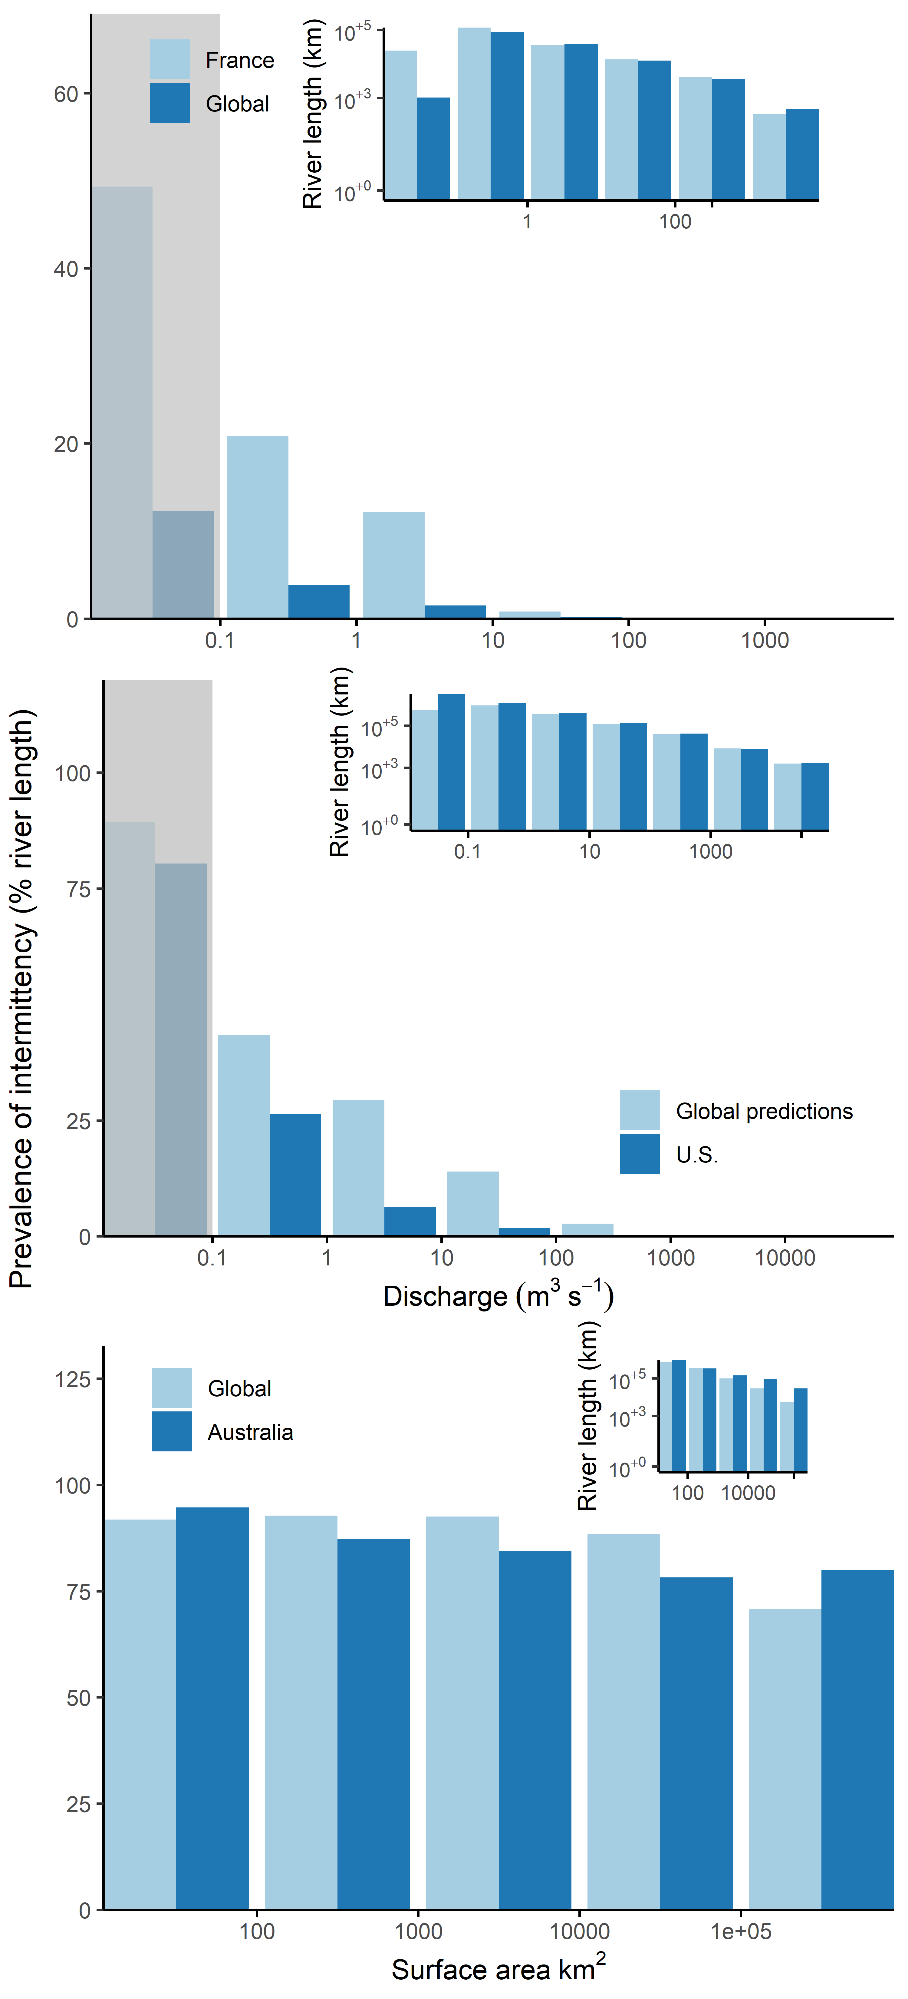

## [1] "Data for comparison, mdur >= 30: US - all"

| bin | perc | binsumlength | dat | binformat |
| --- | --- | --- | --- | --- |
| 1 | 80.4042871 | 3274335.902 | U.S. | 0 - 0.1 |
| 1 | 89.3331828 | 573703.000 | Global predictions | 0 - 0.1 |
| 2 | 26.4190528 | 1214114.253 | U.S. | 0.1 - 0 |
| 2 | 43.4358777 | 909102.430 | Global predictions | 0.1 - 0 |
| 3 | 6.3820353 | 410379.134 | U.S. | 1 - 9 |
| 3 | 29.4141119 | 368646.180 | Global predictions | 1 - 9 |
| 4 | 1.7990943 | 138635.649 | U.S. | 10 - 99 |
| 4 | 13.9855018 | 122846.790 | Global predictions | 10 - 99 |
| 5 | 0.1221212 | 42704.306 | U.S. | 100 - 999 |
| 5 | 2.7638314 | 40914.580 | Global predictions | 100 - 999 |
| 6 | 0.0000000 | 7386.525 | U.S. | 1000 - 9999 |
| 6 | 0.0000000 | 8403.250 | Global predictions | 1000 - 9999 |
| 7 | 0.0000000 | 1731.468 | U.S. | 10000 - 99999 |
| 7 | 0.0000000 | 1586.010 | Global predictions | 10000 - 99999 |
| world | 19.2564041 | NA | U.S. |  |
| world | 35.9367856 | NA | Global predictions |  |

## [1] "Data for comparison, mdur >= 30: US - no artificial"

| bin | perc | binsumlength | dat | binformat |
| --- | --- | --- | --- | --- |
| 1 | 82.240735 | 3201219.490 | U.S. | 0 - 0.1 |
| 1 | 89.333183 | 573703.000 | Global predictions | 0 - 0.1 |
| 2 | 27.822790 | 1152858.814 | U.S. | 0.1 - 0 |
| 2 | 43.435878 | 909102.430 | Global predictions | 0.1 - 0 |
| 3 | 7.055831 | 371190.051 | U.S. | 1 - 9 |
| 3 | 29.414112 | 368646.180 | Global predictions | 1 - 9 |
| 4 | 2.920497 | 85402.796 | U.S. | 10 - 99 |
| 4 | 13.985502 | 122846.790 | Global predictions | 10 - 99 |
| 5 | 2.213067 | 2356.503 | U.S. | 100 - 999 |
| 5 | 2.763831 | 40914.580 | Global predictions | 100 - 999 |
| 6 | 0.000000 | 8.797 | U.S. | 1000 - 9999 |
| 6 | 0.000000 | 8403.250 | Global predictions | 1000 - 9999 |
| 7 | 0.000000 | 1586.010 | Global predictions | 10000 - 99999 |
| world | 21.683254 | NA | U.S. |  |
| world | 35.936786 | NA | Global predictions |  |

## [1] "Data for comparison, mdur >= 30: France"

| bin | perc | binsumlength | dat | binformat |
| --- | --- | --- | --- | --- |
| 1 | 49.3456187 | 24671.396 | France | 0 - 0.1 |
| 1 | 12.3408094 | 1041.990 | Global | 0 - 0.1 |
| 2 | 20.8665522 | 117633.818 | France | 0.1 - 0 |
| 2 | 3.8249953 | 86413.440 | Global | 0.1 - 0 |
| 3 | 12.1569737 | 36726.994 | France | 1 - 9 |
| 3 | 1.5065882 | 38964.860 | Global | 1 - 9 |
| 4 | 0.8252554 | 13859.588 | France | 10 - 99 |
| 4 | 0.2086675 | 12685.250 | Global | 10 - 99 |
| 5 | 0.0000000 | 4165.854 | France | 100 - 999 |
| 5 | 0.0000000 | 3674.000 | Global | 100 - 999 |
| 6 | 0.0000000 | 346.957 | France | 1000 - 9999 |
| 6 | 0.0000000 | 472.340 | Global | 1000 - 9999 |
| world | 16.8614882 | NA | France |  |
| world | 2.7556593 | NA | Global |  |

## [1] "Data for comparison, mdur >= 30: Australia"

| bin | perc | binsumlength | dat | binformat |
| --- | --- | --- | --- | --- |
| 1 | 94.70478 | 940831.36 | Australia | 10 - 100 |
| 1 | 91.84260 | 779660.03 | Global | 10 - 100 |
| 2 | 87.30249 | 340980.24 | Australia | 100 - 999 |
| 2 | 92.80494 | 353102.77 | Global | 100 - 999 |
| 3 | 84.52900 | 142922.98 | Australia | 1000 - 9999 |
| 3 | 92.54287 | 101227.93 | Global | 1000 - 9999 |
| 4 | 78.27274 | 95357.03 | Australia | 10000 - 99999 |
| 4 | 88.43276 | 29489.50 | Global | 10000 - 99999 |
| 5 | 79.93368 | 29177.03 | Australia | 1e+05 - 999999 |
| 5 | 70.85852 | 5491.69 | Global | 1e+05 - 999999 |
| world | 90.84730 | NA | Australia |  |
| world | 91.99619 | NA | Global |  |

## Warning in remove(ft_plot_mdur30): object 'ft_plot_mdur30' not found

## used (Mb) gc trigger (Mb) max used (Mb)  
## Ncells 249303104 13314.3 525768691 28079.1 356151104 19020.6  
## Vcells 636882827 4859.1 1644699078 12548.1 1375516029 10494.4

#Comparison of results with on-the-ground observations for PROSPER 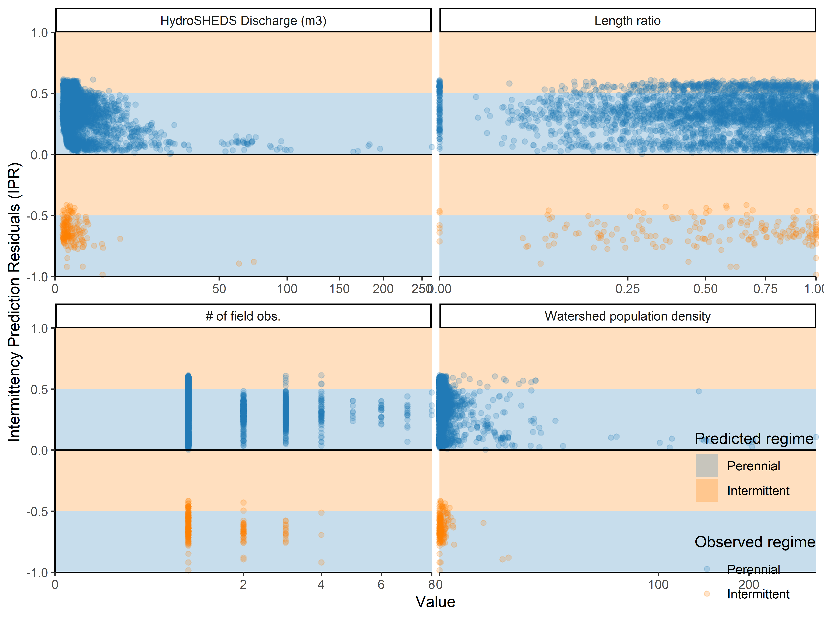

## [1] "Balanced accuracy of predictions based on PROSPER: 0.467"

## [1] "AUC based on PROSPER: 0.572"

## [1] "Misclassification rate based on PROSPER: 0.202"

## [1] "Sensitivity based on PROSPER: 0.101"

## [1] "Specificity rate based on PROSPER: 0.833"

## [1] "Total number of obs: 5372"

## [1] "Total number of reaches: 3725"

## [1] "Total number of perennial reaches: 3547"

## [1] "Total number of non-perennial reaches: 178"

## used (Mb) gc trigger (Mb) max used (Mb)  
## Ncells 249327955 13315.6 525768691 28079.1 356151104 19020.6  
## Vcells 719556775 5489.8 1644699078 12548.1 1375516029 10494.4

#Comparison of results with on-the-ground observations for ONDE 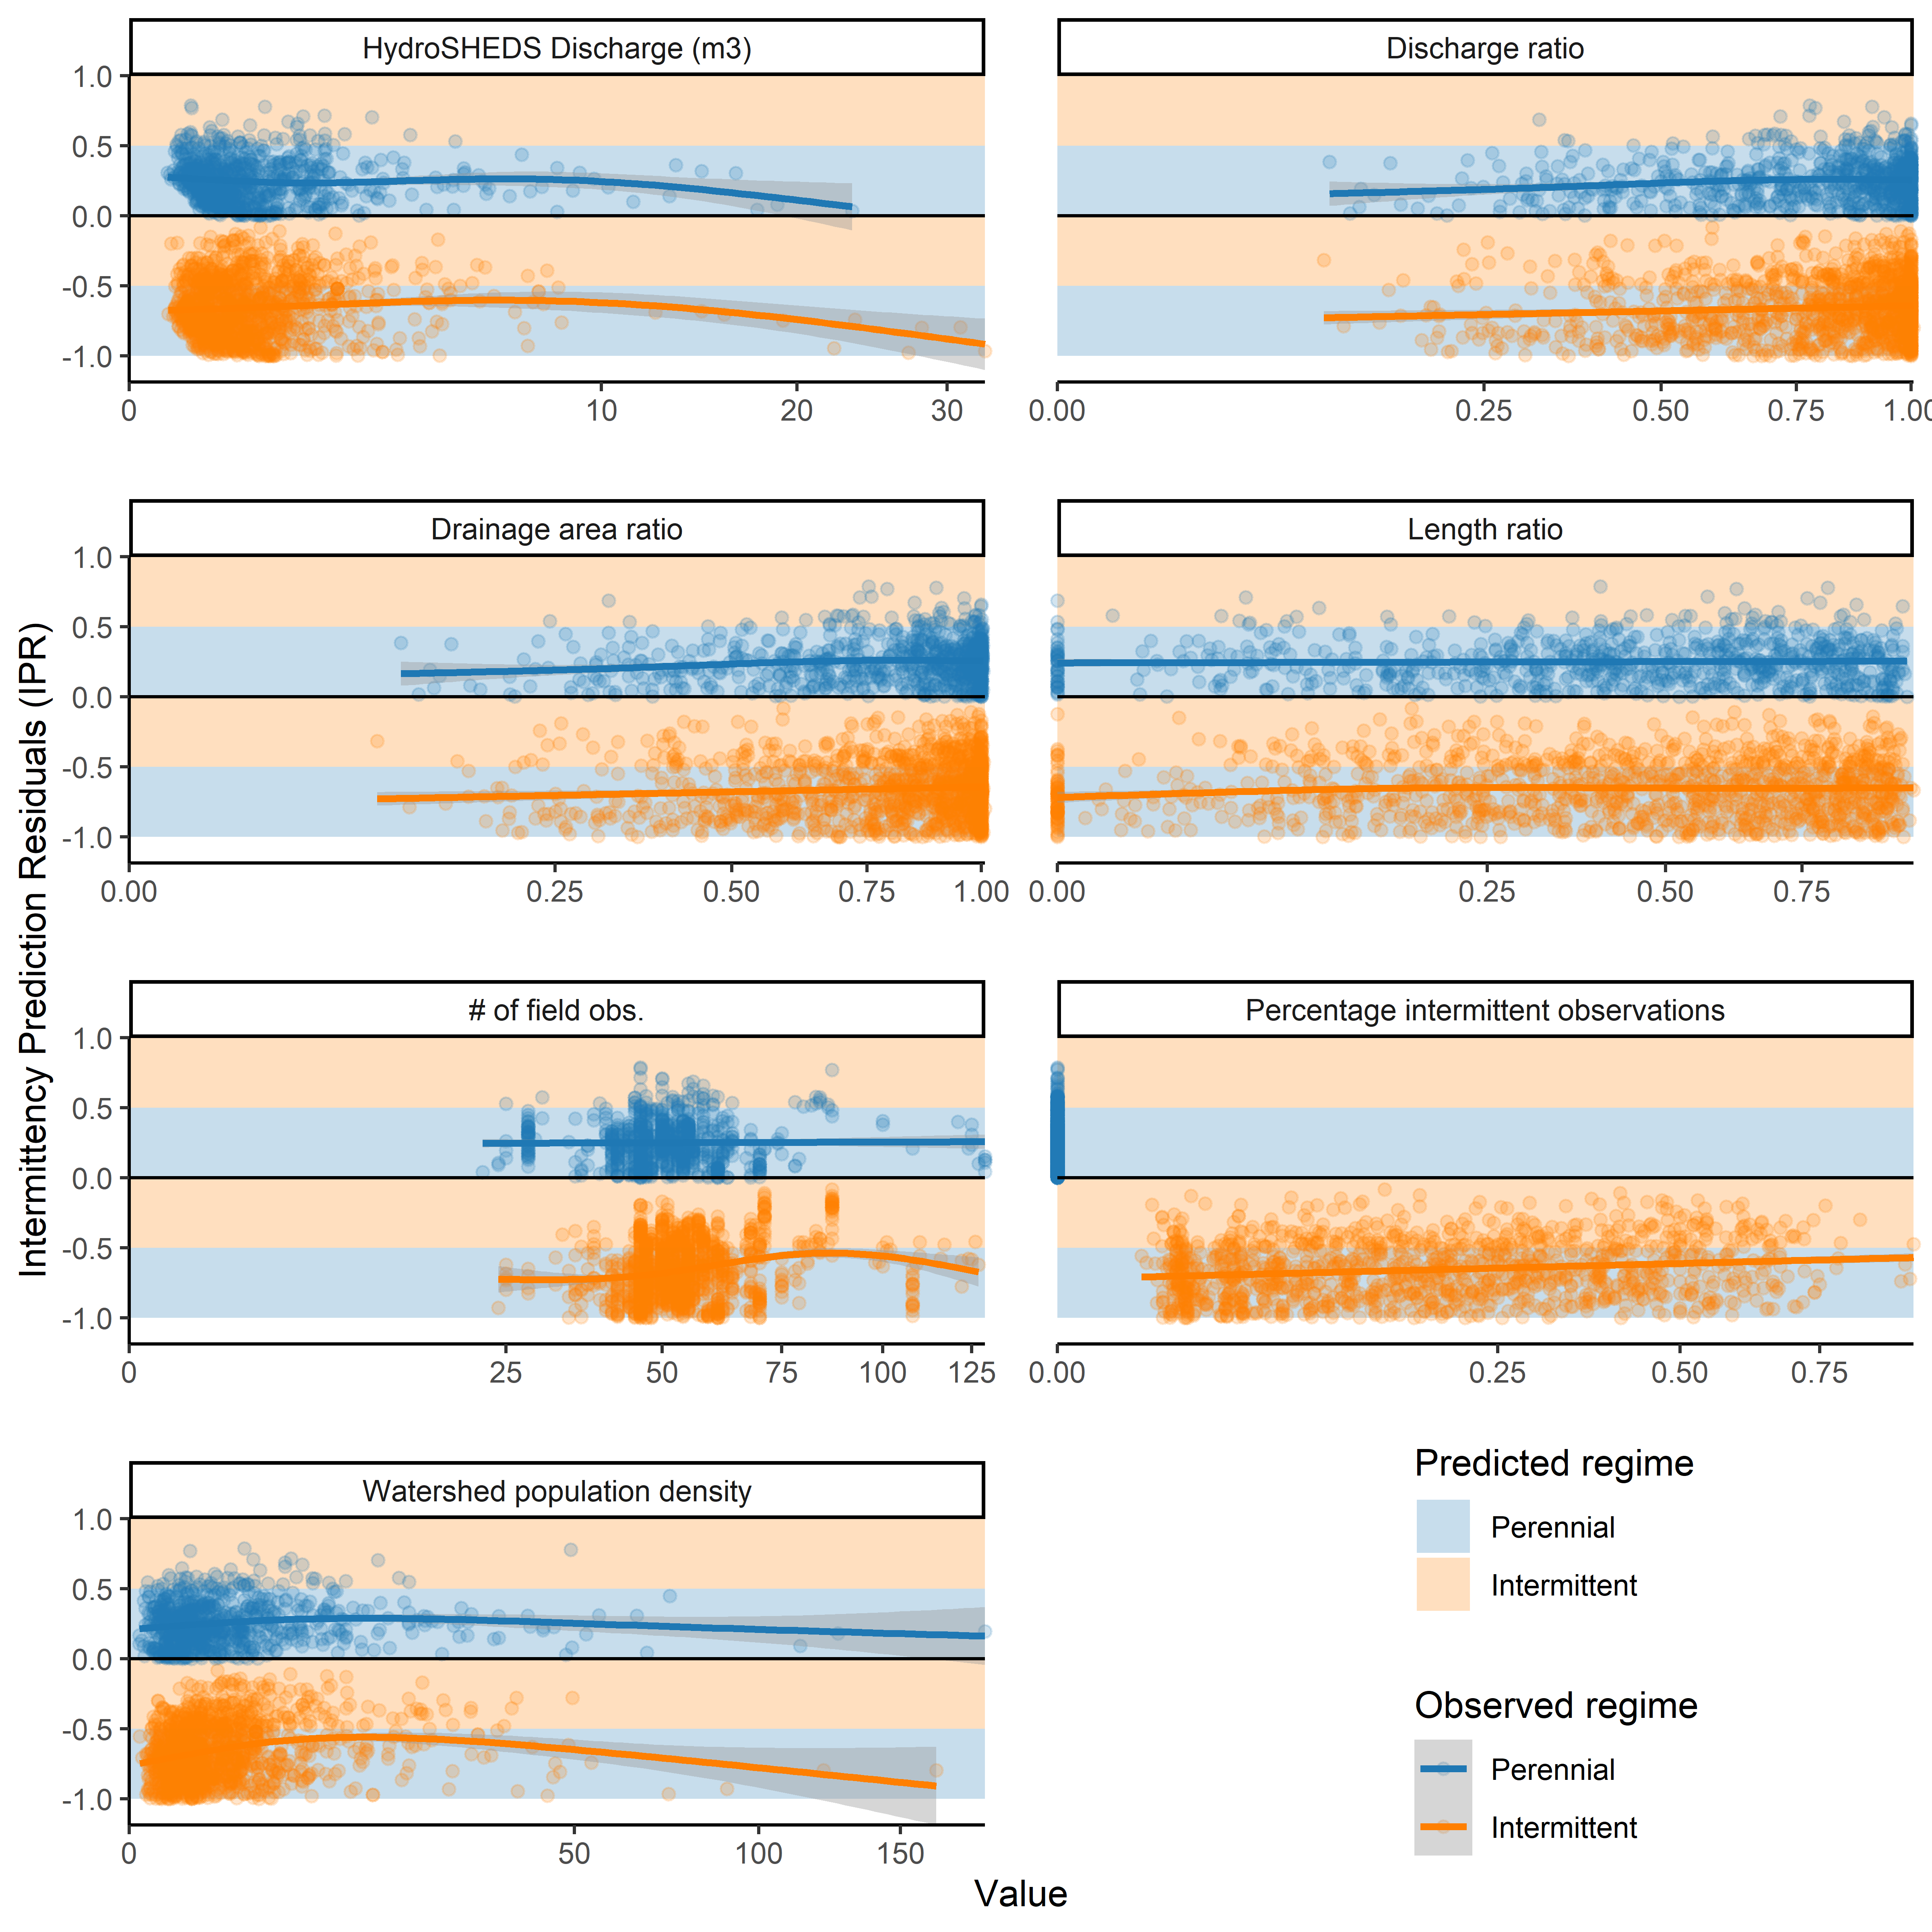

## [1] "Balanced accuracy of predictions based on ONDE: 0.59"

## [1] "AUC based on ONDE: 0.635"

## [1] "Misclassification rate based on ONDE: 0.492"

## [1] "Sensitivity based on ONDE: 0.243"

## [1] "Specificity rate based on ONDE: 0.937"

## [1] "Total number of obs: 124112"

## [1] "Total number of reaches: 2297"

## [1] "Total number of perennial reaches: 878"

## [1] "Total number of non-perennial reaches: 1419"

## used (Mb) gc trigger (Mb) max used (Mb)  
## Ncells 249628014 13331.6 525768691 28079.1 356151104 19020.6  
## Vcells 762462714 5817.2 1644699078 12548.1 1375516029 10494.4

#Environmental variables used in model training + variable selection results

| Category | Attribute | Spatial representation | Temporal/Statistical aggreg. | Source | Citation |
| --- | --- | --- | --- | --- | --- |
| Physiography | Drainage Area | u |  | HydroSHEDS | Lehner & Grill 2013 |
| Hydrology | Natural Discharge | p | mn/mx | WaterGAP v2.2 | DÃ¶ll et al. 2003 |
| Hydrology | Natural Discharge | p | mn/yr | WaterGAP v2.2 | DÃ¶ll et al. 2003 |
| Physiography | Elevation | c | (cav-uav)/uav | EarthEnv-DEM90 | Robinson et al. 2014 |
| Hydrology | Groundwater table depth | c | av | Global Groundwater Map | Fan et al. 2013 |
| Hydrology | Runoff coefficient | c | yr | WaterGAP v2.2, WorldClim v2 | DÃ¶ll et al. 2003 |
| Hydrology | Specific discharge | u | mn | WaterGAP v2.2 | DÃ¶ll et al. 2003 |
| Hydrology | Specific discharge | u | yr | WaterGAP v2.2 | DÃ¶ll et al. 2003 |
| Climate | Actual Evapotranspiration | catchment | Annual average | Global Soil-Water Balance | Trabucco & Zomer 2010 |
| Climate | Actual Evapotranspiration | watershed | Annual average | Global Soil-Water Balance | Trabucco & Zomer 2010 |
| Climate | BIO1 - Annual Mean Temperature | catchment | Average | WorldClim v2 | Fick et al. 2017 |
| Climate | BIO1 - Annual Mean Temperature | watershed | Average | WorldClim v2 | Fick et al. 2017 |
| Climate | BIO10 - Mean Temperature of Warmest Quarter | catchment | Average | WorldClim v2 | Fick et al. 2017 |
| Climate | BIO10 - Mean Temperature of Warmest Quarter | watershed | Average | WorldClim v2 | Fick et al. 2017 |
| Climate | BIO11 - Mean Temperature of Coldest Quarter | catchment | Average | WorldClim v2 | Fick et al. 2017 |
| Climate | BIO11 - Mean Temperature of Coldest Quarter | watershed | Average | WorldClim v2 | Fick et al. 2017 |
| Climate | BIO12 - Annual Precipitation | catchment | Average | WorldClim v2 | Fick et al. 2017 |
| Climate | BIO12 - Annual Precipitation | watershed | Average | WorldClim v2 | Fick et al. 2017 |
| Climate | BIO13 - Precipitation of Wettest Month | catchment | Average | WorldClim v2 | Fick et al. 2017 |
| Climate | BIO13 - Precipitation of Wettest Month | watershed | Average | WorldClim v2 | Fick et al. 2017 |
| Climate | BIO14 - Precipitation of Driest Month | catchment | Average | WorldClim v2 | Fick et al. 2017 |
| Climate | BIO14 - Precipitation of Driest Month | watershed | Average | WorldClim v2 | Fick et al. 2017 |
| Climate | BIO15 - Precipitation Seasonality (Coefficient of Variation) | catchment | Average | WorldClim v2 | Fick et al. 2017 |
| Climate | BIO15 - Precipitation Seasonality (Coefficient of Variation) | watershed | Average | WorldClim v2 | Fick et al. 2017 |
| Climate | BIO16 - Precipitation of Wettest Quarter | catchment | Average | WorldClim v2 | Fick et al. 2017 |
| Climate | BIO16 - Precipitation of Wettest Quarter | watershed | Average | WorldClim v2 | Fick et al. 2017 |
| Climate | BIO17 - Precipitation of Driest Quarter | catchment | Average | WorldClim v2 | Fick et al. 2017 |
| Climate | BIO17 - Precipitation of Driest Quarter | watershed | Average | WorldClim v2 | Fick et al. 2017 |
| Climate | BIO18 - Precipitation of Warmest Quarter | catchment | Average | WorldClim v2 | Fick et al. 2017 |
| Climate | BIO18 - Precipitation of Warmest Quarter | watershed | Average | WorldClim v2 | Fick et al. 2017 |
| Climate | BIO19 - Precipitation of Coldest Quarter | catchment | Average | WorldClim v2 | Fick et al. 2017 |
| Climate | BIO19 - Precipitation of Coldest Quarter | watershed | Average | WorldClim v2 | Fick et al. 2017 |
| Climate | BIO2 - Mean Diurnal Range (Mean of monthly (max temp - min temp)) | catchment | Average | WorldClim v2 | Fick et al. 2017 |
| Climate | BIO2 - Mean Diurnal Range (Mean of monthly (max temp - min temp)) | watershed | Average | WorldClim v2 | Fick et al. 2017 |
| Climate | BIO3 - Isothermality (BIO2/BIO7) (×100) | catchment | Average | WorldClim v2 | Fick et al. 2017 |
| Climate | BIO3 - Isothermality (BIO2/BIO7) (×100) | watershed | Average | WorldClim v2 | Fick et al. 2017 |
| Climate | BIO4 - Temperature Seasonality (standard deviation ×100) | catchment | Average | WorldClim v2 | Fick et al. 2017 |
| Climate | BIO4 - Temperature Seasonality (standard deviation ×100) | watershed | Average | WorldClim v2 | Fick et al. 2017 |
| Climate | BIO5 - Max Temperature of Warmest Month | catchment | Average | WorldClim v2 | Fick et al. 2017 |
| Climate | BIO5 - Max Temperature of Warmest Month | watershed | Average | WorldClim v2 | Fick et al. 2017 |
| Climate | BIO6 - Min Temperature of Coldest Month | catchment | Average | WorldClim v2 | Fick et al. 2017 |
| Climate | BIO6 - Min Temperature of Coldest Month | watershed | Average | WorldClim v2 | Fick et al. 2017 |
| Climate | BIO7 - Temperature Annual Range (BIO5-BIO6) | catchment | Average | WorldClim v2 | Fick et al. 2017 |
| Climate | BIO7 - Temperature Annual Range (BIO5-BIO6) | watershed | Average | WorldClim v2 | Fick et al. 2017 |
| Climate | BIO8 - Mean Temperature of Wettest Quarter | catchment | Average | WorldClim v2 | Fick et al. 2017 |
| Climate | BIO8 - Mean Temperature of Wettest Quarter | watershed | Average | WorldClim v2 | Fick et al. 2017 |
| Climate | BIO9 - Mean Temperature of Driest Quarter | catchment | Average | WorldClim v2 | Fick et al. 2017 |
| Climate | BIO9 - Mean Temperature of Driest Quarter | watershed | Average | WorldClim v2 | Fick et al. 2017 |
| Climate | Climate Moisture Index | catchment | Minimum or Annual minimum | WorldClim v2 & Global-PET v2 | Fick et al. 2017 |
| Climate | Climate Moisture Index | watershed | Minimum or Annual minimum | WorldClim v2 & Global-PET v2 | Fick et al. 2017 |
| Climate | Climate Zones | catchment | Spatial majority (dominant value) | GEnS | Metzger et al. 2013 |
| Climate | Global Aridity Index | catchment | Average | Global Aridity Index v2 | Trabucco & Zomer 2018 |
| Climate | Global Aridity Index | watershed | Average | Global Aridity Index v2 | Trabucco & Zomer 2018 |
| Climate | Potential Evapotranspiration | catchment | Annual average | Global-PET v2 | Trabucco & Zomer 2018 |
| Climate | Potential Evapotranspiration | watershed | Annual average | Global-PET v2 | Trabucco & Zomer 2018 |
| Climate | Snow Cover Extent | catchment | Annual average | MODIS/Aqua | Hall & Riggs 2016 |
| Climate | Snow Cover Extent | catchment | Maximum or Annual maximum | MODIS/Aqua | Hall & Riggs 2016 |
| Climate | Snow Cover Extent | watershed | Annual average | MODIS/Aqua | Hall & Riggs 2016 |
| Hydrology | Inundation Extent | catchment | Minimum or Annual minimum | GIEMS-D15 | Fluet-Chouinard et al. 2015 |
| Hydrology | Inundation Extent | watershed | Maximum or Annual maximum | GIEMS-D15 | Fluet-Chouinard et al. 2015 |
| Hydrology | Inundation Extent | watershed | Minimum or Annual minimum | GIEMS-D15 | Fluet-Chouinard et al. 2015 |
| Hydrology | Land Surface Runoff | catchment | Annual average | WaterGAP v2.2 | Döll et al. 2003 |
| Hydrology | Limnicity (Percent Lake Area) | catchment | Spatial extent (%) | HydroLAKES | Messager et al. 2016 |
| Hydrology | Limnicity (Percent Lake Area) | watershed | Spatial extent (%) | HydroLAKES | Messager et al. 2016 |
| Hydrology | Natural Discharge | pour point | Annual average | WaterGAP v2.2 | Döll et al. 2003 |
| Hydrology | Natural Discharge | pour point | Maximum or Annual maximum | WaterGAP v2.2 | Döll et al. 2003 |
| Hydrology | Natural Discharge | pour point | Minimum or Annual minimum | WaterGAP v2.2 | Döll et al. 2003 |
| Hydrology | Surface water dry period | catchment | Average | GLAD Surface Water Dynamics | Pickens et al. 2020 |
| Hydrology | Surface water dry period | watershed | Average | GLAD Surface Water Dynamics | Pickens et al. 2020 |
| Hydrology | Surface water high frequency | catchment | Average | GLAD Surface Water Dynamics | Pickens et al. 2020 |
| Hydrology | Surface water high frequency | watershed | Average | GLAD Surface Water Dynamics | Pickens et al. 2020 |
| Hydrology | Surface water loss | catchment | Average | GLAD Surface Water Dynamics | Pickens et al. 2020 |
| Hydrology | Surface water loss | watershed | Average | GLAD Surface Water Dynamics | Pickens et al. 2020 |
| Hydrology | Surface water maximum extent | catchment | Average | GLAD Surface Water Dynamics | Pickens et al. 2020 |
| Hydrology | Surface water maximum extent | watershed | Average | GLAD Surface Water Dynamics | Pickens et al. 2020 |
| Hydrology | Surface water permanent | catchment | Average | GLAD Surface Water Dynamics | Pickens et al. 2020 |
| Hydrology | Surface water permanent | watershed | Average | GLAD Surface Water Dynamics | Pickens et al. 2020 |
| Hydrology | Surface water seasonal | catchment | Average | GLAD Surface Water Dynamics | Pickens et al. 2020 |
| Hydrology | Surface water seasonal | watershed | Average | GLAD Surface Water Dynamics | Pickens et al. 2020 |
| Hydrology | Surface water wet period | catchment | Average | GLAD Surface Water Dynamics | Pickens et al. 2020 |
| Hydrology | Surface water wet period | watershed | Average | GLAD Surface Water Dynamics | Pickens et al. 2020 |
| Landcover | Forest Cover Extent | catchment | Spatial extent (%) | GLC2000 | Bartholomé & Belward 2005 |
| Landcover | Forest Cover Extent | watershed | Spatial extent (%) | GLC2000 | Bartholomé & Belward 2005 |
| Landcover | Glacier Extent | catchment | Spatial extent (%) | GLIMS | GLIMS & NSIDC 2012 |
| Landcover | Glacier Extent | watershed | Spatial extent (%) | GLIMS | GLIMS & NSIDC 2012 |
| Landcover | Land Cover Classes | catchment | Spatial majority (dominant value) | GLC2000 | Bartholomé & Belward 2005 |
| Landcover | Land Cover Extent | catchment | Class 16 | GLC2000 | Bartholomé & Belward 2005 |
| Landcover | Land Cover Extent | watershed | Class 16 | GLC2000 | Bartholomé & Belward 2005 |
| Landcover | Permafrost Extent | catchment | Spatial extent (%) | PZI | Gruber 2012 |
| Landcover | Permafrost Extent | watershed | Spatial extent (%) | PZI | Gruber 2012 |
| Landcover | Potential Natural Vegetation Classes | catchment | Spatial majority (dominant value) | EarthStat | Ramankutty & Foley 1999 |
| Landcover | Wetland Extent | catchment | Class 7 | GLWD | Lehner & Döll 2004 |
| Landcover | Wetland Extent | catchment | Class 9 | GLWD | Lehner & Döll 2004 |
| Landcover | Wetland Extent | catchment | Class group 1 | GLWD | Lehner & Döll 2004 |
| Landcover | Wetland Extent | catchment | Class group 2 | GLWD | Lehner & Döll 2004 |
| Landcover | Wetland Extent | watershed | Class 7 | GLWD | Lehner & Döll 2004 |
| Landcover | Wetland Extent | watershed | Class 9 | GLWD | Lehner & Döll 2004 |
| Landcover | Wetland Extent | watershed | Class group 1 | GLWD | Lehner & Döll 2004 |
| Landcover | Wetland Extent | watershed | Class group 2 | GLWD | Lehner & Döll 2004 |
| Physiography | Terrain Slope | catchment | Average | EarthEnv-DEM90 | Robinson et al. 2014 |
| Physiography | Terrain Slope | watershed | Average | EarthEnv-DEM90 | Robinson et al. 2014 |
| Soils & Geology | Clay Fraction in Soil 0-100 cm | catchment | Average | SoilGrids250m v2 | Hengl et al. 2017 |
| Soils & Geology | Clay Fraction in Soil 0-100 cm | watershed | Average | SoilGrids250m v2 | Hengl et al. 2017 |
| Soils & Geology | Karst Area Extent | catchment | Spatial extent (%) | Rock Outcrops v3.0 | Williams & Ford 2006 |
| Soils & Geology | Karst Area Extent | watershed | Spatial extent (%) | Rock Outcrops v3.0 | Williams & Ford 2006 |
| Soils & Geology | Lithological Classes | catchment | Spatial majority (dominant value) | GLiM | Hartmann & Moosdorf 2012 |
| Soils & Geology | Sand Fraction in Soil 0-100 cm | catchment | Average | SoilGrids250m v2 | Hengl et al. 2017 |
| Soils & Geology | Sand Fraction in Soil 0-100 cm | watershed | Average | SoilGrids250m v2 | Hengl et al. 2017 |
| Soils & Geology | Silt Fraction in Soil 0-100 cm | catchment | Average | SoilGrids250m v2 | Hengl et al. 2017 |
| Soils & Geology | Silt Fraction in Soil 0-100 cm | watershed | Average | SoilGrids250m v2 | Hengl et al. 2017 |
| Soils & Geology | Soil Water Content | catchment | Annual average | Global Soil-Water Balance | Trabucco & Zomer 2010 |
| Soils & Geology | Soil Water Content | catchment | Minimum or Annual minimum | Global Soil-Water Balance | Trabucco & Zomer 2010 |
| Soils & Geology | Soil Water Content | watershed | Annual average | Global Soil-Water Balance | Trabucco & Zomer 2010 |

## used (Mb) gc trigger (Mb) max used (Mb)  
## Ncells 249546221 13327.3 525768691 28079.1 356151104 19020.6  
## Vcells 762405031 5816.7 1644699078 12548.1 1375516029 10494.4

#Tables of intermittence by categories for base model

| clz_cl_cmj | 0.1-1 | | 1-10 | | 10-100 | | | 100-999.94 | | | | | 1000.01-9999.84 | | | | | 10001.33-205603.69 | | | | Total intermittency (%) | | | | | Total stream length (10^3 km) | | | | |
| --- | --- | --- | --- | --- | --- | --- | --- | --- | --- | --- | --- | --- | --- | --- | --- | --- | --- | --- | --- | --- | --- | --- | --- | --- | --- | --- | --- | --- | --- | --- | --- |
| World | 47 | | 35 | | 26 | | | 9 | | | | | 1 | | | | | 0 | | | | 41 | | | | | 23291 | | | | |
| Extremely hot and moist | 18 | | 20 | | 21 | | | 4 | | | | | 0 | | | | | 0 | | | | 18 | | | | | 6002 | | | | |
| Cold and mesic | 47 | | 26 | | 6 | | | 3 | | | | | 0 | | | | | 0 | | | | 37 | | | | | 3084 | | | | |
| Extremely cold and mesic | 70 | | 45 | | 34 | | | 26 | | | | | 22 | | | | | 0 | | | | 61 | | | | | 3051 | | | | |
| Hot and mesic | 30 | | 24 | | 23 | | | 5 | | | | | 0 | | | | | 0 | | | | 27 | | | | | 2023 | | | | |
| Hot and dry | 47 | | 36 | | 23 | | | 7 | | | | | 0 | | | | | 0 | | | | 41 | | | | | 1683 | | | | |
| Warm temperate and mesic | 45 | | 35 | | 16 | | | 1 | | | | | 0 | | | | | 0 | | | | 39 | | | | | 1646 | | | | |
| Extremely hot and xeric | 90 | | 95 | | 90 | | | 45 | | | | | 0 | | | | | 0 | | | | 89 | | | | | 1605 | | | | |
| Cool temperate and dry | 46 | | 34 | | 11 | | | 0 | | | | | 0 | | | | | 0 | | | | 39 | | | | | 1325 | | | | |
| Cool temperate and moist | 18 | | 10 | | 0 | | | 0 | | | | | 0 | | | | | NA | | | | 13 | | | | | 691 | | | | |
| Cool temperate and xeric | 81 | | 70 | | 37 | | | 2 | | | | | 0 | | | | | NA | | | | 72 | | | | | 552 | | | | |
| Warm temperate and xeric | 96 | | 89 | | 59 | | | 11 | | | | | 0 | | | | | 0 | | | | 89 | | | | | 444 | | | | |
| Cold and wet | 1 | | 0 | | 0 | | | 0 | | | | | 0 | | | | | NA | | | | 1 | | | | | 299 | | | | |
| Extremely hot and arid | 100 | | 100 | | 98 | | | 49 | | | | | 0 | | | | | NA | | | | 98 | | | | | 249 | | | | |
| Extremely cold and wet 2 | 93 | | 69 | | 34 | | | 0 | | | | | NA | | | | | NA | | | | 87 | | | | | 243 | | | | |
| Hot and arid | 100 | | 100 | | 97 | | | 46 | | | | | 0 | | | | | NA | | | | 98 | | | | | 238 | | | | |
| Extremely cold and wet 1 | 59 | | 10 | | 1 | | | 0 | | | | | NA | | | | | NA | | | | 50 | | | | | 109 | | | | |
| Arctic 2 | 89 | | 18 | | 8 | | | NA | | | | | NA | | | | | NA | | | | 82 | | | | | 41 | | | | |
| Arctic 1 | 92 | | 71 | | 100 | | | NA | | | | | NA | | | | | NA | | | | 92 | | | | | 6 | | | | |
| tbi_cl_cmj | | | | | | | | | 0.1-1 | | 1-10 | | | 10-100 | | | 100-999.94 | | | | 1000.01-9999.84 | | | | 10001.33-205603.69 | | | Total intermittency (%) | | | Total stream length (10^3 km) | | | |
| World | | | | | | | | | 47 | | 35 | | | 26 | | | 9 | | | | 1 | | | | 0 | | | 41 | | | 23291 | | | |
| Tropical & Subtropical Moist Broadleaf Forests | | | | | | | | | 7 | | 10 | | | 13 | | | 3 | | | | 0 | | | | 0 | | | 8 | | | 6397 | | | |
| Tropical & Subtropical Grasslands, Savannas & Shrublands | | | | | | | | | 59 | | 57 | | | 52 | | | 21 | | | | 0 | | | | 0 | | | 57 | | | 3409 | | | |
| Boreal Forests/Taiga | | | | | | | | | 61 | | 31 | | | 14 | | | 10 | | | | 2 | | | | 0 | | | 48 | | | 3091 | | | |
| Temperate Broadleaf & Mixed Forests | | | | | | | | | 27 | | 19 | | | 8 | | | 0 | | | | 0 | | | | 0 | | | 22 | | | 2815 | | | |
| Tundra | | | | | | | | | 83 | | 61 | | | 42 | | | 24 | | | | 27 | | | | 0 | | | 74 | | | 1681 | | | |
| Deserts & Xeric Shrublands | | | | | | | | | 94 | | 90 | | | 67 | | | 35 | | | | 0 | | | | NA | | | 90 | | | 1312 | | | |
| Temperate Grasslands, Savannas & Shrublands | | | | | | | | | 83 | | 73 | | | 35 | | | 3 | | | | 0 | | | | 0 | | | 74 | | | 1232 | | | |
| Tropical & Subtropical Dry Broadleaf Forests | | | | | | | | | 65 | | 70 | | | 62 | | | 22 | | | | 0 | | | | 0 | | | 65 | | | 841 | | | |
| Temperate Conifer Forests | | | | | | | | | 25 | | 14 | | | 3 | | | 0 | | | | 0 | | | | NA | | | 20 | | | 812 | | | |
| Montane Grasslands & Shrublands | | | | | | | | | 53 | | 30 | | | 6 | | | 1 | | | | 0 | | | | NA | | | 45 | | | 631 | | | |
| Mediterranean Forests, Woodlands & Scrub | | | | | | | | | 80 | | 70 | | | 50 | | | 17 | | | | 0 | | | | NA | | | 75 | | | 429 | | | |
| N/A | | | | | | | | | 74 | | 22 | | | 18 | | | 0 | | | | NA | | | | NA | | | 66 | | | 250 | | | |
| Flooded Grasslands & Savannas | | | | | | | | | 77 | | 72 | | | 45 | | | 14 | | | | 0 | | | | 0 | | | 66 | | | 178 | | | |
| Tropical & Subtropical Coniferous Forests | | | | | | | | | 31 | | 17 | | | 9 | | | 1 | | | | 0 | | | | NA | | | 26 | | | 128 | | | |
| Mangroves | | | | | | | | | 25 | | 51 | | | 38 | | | 6 | | | | 0 | | | | 0 | | | 33 | | | 84 | | | |
| fmh_cl_cmj | | | | | | | 0.1-1 | | | 1-10 | | 10-100 | | | | 100-999.94 | | | 1000.01-9999.84 | | | | 10001.33-205603.69 | | | Total intermittency (%) | | | | Total stream length (10^3 km) | | | |
| World | | | | | | | 47 | | | 35 | | 26 | | | | 9 | | | 1 | | | | 0 | | | 41 | | | | 23291 | | | |
| Tropical and subtropical floodplain rivers and wetlands | | | | | | | 36 | | | 36 | | 40 | | | | 13 | | | 0 | | | | 0 | | | 35 | | | | 3821 | | | |
| Polar freshwaters | | | | | | | 78 | | | 54 | | 31 | | | | 16 | | | 6 | | | | 0 | | | 67 | | | | 3665 | | | |
| Tropical and subtropical coastal rivers | | | | | | | 30 | | | 29 | | 30 | | | | 12 | | | 0 | | | | NA | | | 29 | | | | 3000 | | | |
| Temperate coastal rivers | | | | | | | 36 | | | 19 | | 10 | | | | 3 | | | 0 | | | | 0 | | | 28 | | | | 2898 | | | |
| Tropical and subtropical upland rivers | | | | | | | 17 | | | 15 | | 13 | | | | 2 | | | 0 | | | | 0 | | | 15 | | | | 2485 | | | |
| Temperate floodplain rivers and wetlands | | | | | | | 45 | | | 36 | | 19 | | | | 5 | | | 0 | | | | 0 | | | 39 | | | | 2448 | | | |
| Xeric freshwaters and endorheic basins | | | | | | | 89 | | | 84 | | 68 | | | | 40 | | | 0 | | | | NA | | | 86 | | | | 1833 | | | |
| Temperate upland rivers | | | | | | | 59 | | | 45 | | 19 | | | | 3 | | | 0 | | | | 0 | | | 50 | | | | 1103 | | | |
| Montane freshwaters | | | | | | | 18 | | | 9 | | 4 | | | | 0 | | | 0 | | | | 0 | | | 13 | | | | 975 | | | |
| Large lakes | | | | | | | 53 | | | 37 | | 17 | | | | 2 | | | 0 | | | | NA | | | 45 | | | | 489 | | | |
| Greenland | | | | | | | 78 | | | 38 | | 29 | | | | 8 | | | NA | | | | NA | | | 71 | | | | 282 | | | |
| Large river deltas | | | | | | | 19 | | | 39 | | 36 | | | | 1 | | | 0 | | | | 0 | | | 26 | | | | 276 | | | |
| Oceanic islands | | | | | | | 12 | | | 9 | | 3 | | | | 0 | | | NA | | | | NA | | | 11 | | | | 13 | | | |
| No Data | | | | | | | 71 | | | 79 | | NA | | | | NA | | | NA | | | | NA | | | 72 | | | | 2 | | | |
| gad_id_cmj | | 0.1-1 | | 1-10 | | 10-100 | | | | 100-999.94 | | | | | 1000.01-9999.84 | | | | | 10001.33-205603.69 | | | | Total intermittency (%) | | | | | Total stream length (10^3 km) | | | |
| World | | 47 | | 35 | | 26 | | | | 9 | | | | | 1 | | | | | 0 | | | | 41 | | | | | 23291 | | | |
| Russia | | 70 | | 44 | | 24 | | | | 14 | | | | | 6 | | | | | 0 | | | | 59 | | | | | 3359 | | | |
| Brazil | | 12 | | 10 | | 9 | | | | 0 | | | | | 0 | | | | | 0 | | | | 11 | | | | | 2378 | | | |
| Canada | | 54 | | 32 | | 13 | | | | 3 | | | | | 0 | | | | | 0 | | | | 44 | | | | | 1782 | | | |
| United States | | 58 | | 46 | | 21 | | | | 3 | | | | | 0 | | | | | 0 | | | | 50 | | | | | 1728 | | | |
| China | | 46 | | 28 | | 13 | | | | 1 | | | | | 0 | | | | | 0 | | | | 37 | | | | | 1410 | | | |
| India | | 71 | | 74 | | 76 | | | | 44 | | | | | 0 | | | | | 0 | | | | 71 | | | | | 765 | | | |
| Indonesia | | 1 | | 2 | | 1 | | | | 0 | | | | | 0 | | | | | NA | | | | 1 | | | | | 701 | | | |
| Australia | | 91 | | 90 | | 85 | | | | 69 | | | | | 0 | | | | | NA | | | | 90 | | | | | 674 | | | |
| Democratic Republic of the Congo | | 7 | | 7 | | 4 | | | | 0 | | | | | 0 | | | | | 0 | | | | 7 | | | | | 558 | | | |
| Colombia | | 3 | | 18 | | 19 | | | | 1 | | | | | 0 | | | | | 0 | | | | 10 | | | | | 467 | | | |
| Peru | | 7 | | 3 | | 1 | | | | 0 | | | | | 0 | | | | | 0 | | | | 5 | | | | | 422 | | | |
| Argentina | | 85 | | 75 | | 32 | | | | 7 | | | | | 0 | | | | | 0 | | | | 76 | | | | | 322 | | | |
| Venezuela | | 19 | | 32 | | 29 | | | | 1 | | | | | 0 | | | | | 0 | | | | 23 | | | | | 284 | | | |
| Greenland | | 78 | | 38 | | 29 | | | | 8 | | | | | NA | | | | | NA | | | | 71 | | | | | 282 | | | |
| Mexico | | 62 | | 55 | | 47 | | | | 14 | | | | | 0 | | | | | NA | | | | 58 | | | | | 266 | | | |
| Myanmar | | 11 | | 29 | | 40 | | | | 14 | | | | | 0 | | | | | 0 | | | | 19 | | | | | 248 | | | |
| Angola | | 43 | | 37 | | 24 | | | | 4 | | | | | 0 | | | | | 0 | | | | 38 | | | | | 227 | | | |
| Bolivia | | 27 | | 31 | | 21 | | | | 1 | | | | | 0 | | | | | 0 | | | | 26 | | | | | 209 | | | |
| Nigeria | | 60 | | 68 | | 81 | | | | 28 | | | | | 0 | | | | | NA | | | | 63 | | | | | 203 | | | |
| Iran | | 81 | | 76 | | 68 | | | | 13 | | | | | 0 | | | | | NA | | | | 78 | | | | | 201 | | | |
| Papua New Guinea | | 0 | | 3 | | 4 | | | | 0 | | | | | 0 | | | | | NA | | | | 2 | | | | | 188 | | | |
| Ethiopia | | 62 | | 52 | | 46 | | | | 35 | | | | | 0 | | | | | NA | | | | 58 | | | | | 187 | | | |
| Tanzania | | 72 | | 73 | | 63 | | | | 15 | | | | | 0 | | | | | NA | | | | 71 | | | | | 173 | | | |
| Madagascar | | 37 | | 33 | | 25 | | | | 10 | | | | | 0 | | | | | NA | | | | 34 | | | | | 170 | | | |
| Mozambique | | 79 | | 80 | | 72 | | | | 38 | | | | | 0 | | | | | NA | | | | 77 | | | | | 162 | | | |
| Turkey | | 42 | | 40 | | 21 | | | | 1 | | | | | NA | | | | | NA | | | | 39 | | | | | 149 | | | |
| Kazakhstan | | 93 | | 85 | | 58 | | | | 0 | | | | | 0 | | | | | NA | | | | 85 | | | | | 149 | | | |
| France | | 16 | | 14 | | 1 | | | | 0 | | | | | 0 | | | | | NA | | | | 14 | | | | | 138 | | | |
| Zambia | | 76 | | 78 | | 51 | | | | 5 | | | | | 0 | | | | | NA | | | | 72 | | | | | 135 | | | |
| Chile | | 26 | | 14 | | 3 | | | | 0 | | | | | NA | | | | | NA | | | | 20 | | | | | 133 | | | |
| Thailand | | 33 | | 59 | | 68 | | | | 6 | | | | | 0 | | | | | NA | | | | 42 | | | | | 133 | | | |
| Malaysia | | 0 | | 0 | | 1 | | | | 0 | | | | | 0 | | | | | NA | | | | 0 | | | | | 128 | | | |
| Central African Republic | | 29 | | 28 | | 29 | | | | 2 | | | | | 0 | | | | | NA | | | | 28 | | | | | 126 | | | |
| Cameroon | | 14 | | 12 | | 12 | | | | 2 | | | | | 0 | | | | | NA | | | | 13 | | | | | 126 | | | |
| Japan | | 0 | | 0 | | 0 | | | | 0 | | | | | NA | | | | | NA | | | | 0 | | | | | 124 | | | |
| Vietnam | | 2 | | 21 | | 31 | | | | 0 | | | | | 0 | | | | | 0 | | | | 10 | | | | | 108 | | | |
| Philippines | | 0 | | 13 | | 16 | | | | 2 | | | | | 0 | | | | | NA | | | | 6 | | | | | 106 | | | |
| South Africa | | 85 | | 88 | | 80 | | | | 58 | | | | | NA | | | | | NA | | | | 85 | | | | | 106 | | | |
| Pakistan | | 88 | | 76 | | 65 | | | | 21 | | | | | 0 | | | | | NA | | | | 80 | | | | | 101 | | | |
| Sudan | | 100 | | 100 | | 100 | | | | 99 | | | | | 0 | | | | | NA | | | | 97 | | | | | 100 | | | |
| Ukraine | | 12 | | 6 | | 0 | | | | 0 | | | | | 0 | | | | | NA | | | | 10 | | | | | 95 | | | |
| Algeria | | 99 | | 100 | | 99 | | | | NA | | | | | NA | | | | | NA | | | | 99 | | | | | 94 | | | |
| Ecuador | | 8 | | 4 | | 1 | | | | 0 | | | | | 0 | | | | | NA | | | | 5 | | | | | 94 | | | |
| Kenya | | 82 | | 71 | | 75 | | | | 44 | | | | | NA | | | | | NA | | | | 79 | | | | | 90 | | | |
| New Zealand | | 2 | | 1 | | 0 | | | | 0 | | | | | NA | | | | | NA | | | | 1 | | | | | 90 | | | |
| Sweden | | 13 | | 0 | | 0 | | | | 0 | | | | | NA | | | | | NA | | | | 8 | | | | | 89 | | | |
| Spain | | 64 | | 51 | | 46 | | | | 17 | | | | | NA | | | | | NA | | | | 59 | | | | | 89 | | | |
| Republic of Congo | | 0 | | 0 | | 0 | | | | 0 | | | | | 0 | | | | | 0 | | | | 0 | | | | | 88 | | | |
| Chad | | 100 | | 100 | | 100 | | | | 30 | | | | | 0 | | | | | NA | | | | 98 | | | | | 85 | | | |
| Mali | | 100 | | 100 | | 100 | | | | 36 | | | | | 0 | | | | | NA | | | | 97 | | | | | 85 | | | |
| Gabon | | 0 | | 0 | | 0 | | | | 0 | | | | | 0 | | | | | NA | | | | 0 | | | | | 84 | | | |
| Norway | | 6 | | 0 | | 0 | | | | 0 | | | | | NA | | | | | NA | | | | 4 | | | | | 83 | | | |
| Germany | | 1 | | 0 | | 0 | | | | 0 | | | | | 0 | | | | | NA | | | | 0 | | | | | 83 | | | |
| Afghanistan | | 45 | | 25 | | 12 | | | | 2 | | | | | 0 | | | | | NA | | | | 37 | | | | | 79 | | | |
| Italy | | 48 | | 30 | | 4 | | | | 0 | | | | | 0 | | | | | NA | | | | 38 | | | | | 75 | | | |
| South Sudan | | 81 | | 82 | | 80 | | | | 33 | | | | | 0 | | | | | NA | | | | 77 | | | | | 74 | | | |
| Laos | | 0 | | 12 | | 19 | | | | 0 | | | | | 0 | | | | | NA | | | | 5 | | | | | 72 | | | |
| Guyana | | 4 | | 9 | | 6 | | | | 0 | | | | | 0 | | | | | NA | | | | 5 | | | | | 72 | | | |
| Saudi Arabia | | 100 | | 100 | | 100 | | | | 92 | | | | | NA | | | | | NA | | | | 100 | | | | | 71 | | | |
| Cote d'Ivoire | | 42 | | 46 | | 56 | | | | 18 | | | | | NA | | | | | NA | | | | 43 | | | | | 70 | | | |
| Guinea | | 22 | | 45 | | 47 | | | | 25 | | | | | NA | | | | | NA | | | | 31 | | | | | 69 | | | |
| Mongolia | | 100 | | 97 | | 16 | | | | 0 | | | | | NA | | | | | NA | | | | 90 | | | | | 69 | | | |
| United Kingdom | | 0 | | 0 | | 0 | | | | 0 | | | | | NA | | | | | NA | | | | 0 | | | | | 68 | | | |
| Finland | | 41 | | 0 | | 0 | | | | 0 | | | | | NA | | | | | NA | | | | 27 | | | | | 64 | | | |
| Paraguay | | 58 | | 54 | | 42 | | | | 19 | | | | | 0 | | | | | 0 | | | | 53 | | | | | 63 | | | |
| Poland | | 0 | | 0 | | 0 | | | | 0 | | | | | 0 | | | | | NA | | | | 0 | | | | | 63 | | | |
| Cambodia | | 9 | | 59 | | 69 | | | | 7 | | | | | 0 | | | | | 0 | | | | 29 | | | | | 58 | | | |
| Bangladesh | | 20 | | 84 | | 87 | | | | 12 | | | | | 0 | | | | | 0 | | | | 43 | | | | | 56 | | | |
| Zimbabwe | | 96 | | 94 | | 96 | | | | 100 | | | | | 0 | | | | | NA | | | | 95 | | | | | 54 | | | |
| Morocco | | 94 | | 93 | | 94 | | | | 100 | | | | | NA | | | | | NA | | | | 94 | | | | | 53 | | | |
| Romania | | 39 | | 27 | | 1 | | | | 0 | | | | | 0 | | | | | NA | | | | 32 | | | | | 51 | | | |
| Ghana | | 45 | | 60 | | 63 | | | | 29 | | | | | 0 | | | | | NA | | | | 48 | | | | | 50 | | | |
| Niger | | 100 | | 100 | | 100 | | | | 0 | | | | | 0 | | | | | NA | | | | 99 | | | | | 50 | | | |
| Nepal | | 14 | | 23 | | 11 | | | | 0 | | | | | 0 | | | | | NA | | | | 16 | | | | | 49 | | | |
| Uruguay | | 23 | | 18 | | 1 | | | | 0 | | | | | 0 | | | | | NA | | | | 19 | | | | | 48 | | | |
| Suriname | | 3 | | 4 | | 2 | | | | 0 | | | | | 0 | | | | | NA | | | | 3 | | | | | 45 | | | |
| Libya | | 100 | | 100 | | 100 | | | | NA | | | | | NA | | | | | NA | | | | 100 | | | | | 43 | | | |
| Somalia | | 100 | | 100 | | 100 | | | | 79 | | | | | NA | | | | | NA | | | | 99 | | | | | 42 | | | |
| Belarus | | 0 | | 0 | | 0 | | | | 0 | | | | | NA | | | | | NA | | | | 0 | | | | | 42 | | | |
| Uganda | | 57 | | 54 | | 14 | | | | 0 | | | | | 0 | | | | | NA | | | | 51 | | | | | 42 | | | |
| Iceland | | 2 | | 0 | | 0 | | | | 0 | | | | | NA | | | | | NA | | | | 1 | | | | | 42 | | | |
| Nicaragua | | 4 | | 8 | | 10 | | | | 0 | | | | | 0 | | | | | NA | | | | 5 | | | | | 41 | | | |
| Liberia | | 0 | | 1 | | 2 | | | | 0 | | | | | NA | | | | | NA | | | | 0 | | | | | 39 | | | |
| Guatemala | | 3 | | 14 | | 10 | | | | 0 | | | | | 0 | | | | | NA | | | | 7 | | | | | 37 | | | |
| Iraq | | 90 | | 83 | | 77 | | | | 1 | | | | | 0 | | | | | NA | | | | 80 | | | | | 36 | | | |
| Namibia | | 100 | | 100 | | 100 | | | | 2 | | | | | 0 | | | | | NA | | | | 98 | | | | | 36 | | | |
| Kyrgyzstan | | 59 | | 29 | | 0 | | | | 0 | | | | | NA | | | | | NA | | | | 48 | | | | | 34 | | | |
| Mauritania | | 100 | | 100 | | 100 | | | | 41 | | | | | NA | | | | | NA | | | | 99 | | | | | 33 | | | |
| Honduras | | 4 | | 8 | | 5 | | | | 0 | | | | | NA | | | | | NA | | | | 5 | | | | | 33 | | | |
| French Guiana | | 0 | | 0 | | 0 | | | | 0 | | | | | 0 | | | | | NA | | | | 0 | | | | | 32 | | | |
| Sierra Leone | | 0 | | 38 | | 44 | | | | 9 | | | | | NA | | | | | NA | | | | 15 | | | | | 31 | | | |
| North Korea | | 1 | | 0 | | 0 | | | | 0 | | | | | NA | | | | | NA | | | | 0 | | | | | 29 | | | |
| Tajikistan | | 62 | | 22 | | 7 | | | | 0 | | | | | 0 | | | | | NA | | | | 46 | | | | | 28 | | | |
| Botswana | | 100 | | 100 | | 100 | | | | 26 | | | | | 0 | | | | | NA | | | | 98 | | | | | 27 | | | |
| Panama | | 2 | | 7 | | 5 | | | | 0 | | | | | NA | | | | | NA | | | | 4 | | | | | 27 | | | |
| Burkina Faso | | 100 | | 100 | | 100 | | | | 100 | | | | | NA | | | | | NA | | | | 100 | | | | | 26 | | | |
| South Korea | | 0 | | 0 | | 0 | | | | 0 | | | | | NA | | | | | NA | | | | 0 | | | | | 25 | | | |
| Cuba | | 25 | | 58 | | 63 | | | | 0 | | | | | NA | | | | | NA | | | | 37 | | | | | 24 | | | |
| Malawi | | 66 | | 70 | | 56 | | | | 0 | | | | | 0 | | | | | NA | | | | 65 | | | | | 23 | | | |
| Greece | | 61 | | 53 | | 18 | | | | 0 | | | | | NA | | | | | NA | | | | 57 | | | | | 23 | | | |
| Yemen | | 100 | | 100 | | 100 | | | | NA | | | | | NA | | | | | NA | | | | 100 | | | | | 23 | | | |
| Austria | | 0 | | 0 | | 0 | | | | 0 | | | | | 0 | | | | | NA | | | | 0 | | | | | 23 | | | |
| Bulgaria | | 44 | | 34 | | 1 | | | | 0 | | | | | 0 | | | | | NA | | | | 38 | | | | | 22 | | | |
| Costa Rica | | 1 | | 4 | | 5 | | | | 0 | | | | | 0 | | | | | NA | | | | 2 | | | | | 22 | | | |
| Benin | | 98 | | 100 | | 97 | | | | 65 | | | | | 0 | | | | | NA | | | | 97 | | | | | 22 | | | |
| Portugal | | 85 | | 71 | | 32 | | | | 27 | | | | | NA | | | | | NA | | | | 76 | | | | | 21 | | | |
| Ireland | | 0 | | 0 | | 0 | | | | 0 | | | | | NA | | | | | NA | | | | 0 | | | | | 20 | | | |
| Georgia | | 13 | | 3 | | 0 | | | | 0 | | | | | NA | | | | | NA | | | | 9 | | | | | 19 | | | |
| Senegal | | 100 | | 100 | | 100 | | | | 77 | | | | | NA | | | | | NA | | | | 99 | | | | | 19 | | | |
| Uzbekistan | | 74 | | 52 | | 6 | | | | 0 | | | | | 0 | | | | | NA | | | | 58 | | | | | 18 | | | |
| Sri Lanka | | 11 | | 51 | | 51 | | | | 0 | | | | | NA | | | | | NA | | | | 28 | | | | | 18 | | | |
| Czech Republic | | 0 | | 0 | | 0 | | | | 0 | | | | | NA | | | | | NA | | | | 0 | | | | | 17 | | | |
| Hungary | | 37 | | 42 | | 0 | | | | 0 | | | | | 0 | | | | | NA | | | | 33 | | | | | 16 | | | |
| Latvia | | 5 | | 0 | | 0 | | | | 0 | | | | | NA | | | | | NA | | | | 3 | | | | | 15 | | | |
| Serbia | | 34 | | 27 | | 8 | | | | 0 | | | | | 0 | | | | | NA | | | | 29 | | | | | 15 | | | |
| Lithuania | | 1 | | 0 | | 0 | | | | 0 | | | | | NA | | | | | NA | | | | 1 | | | | | 15 | | | |
| Turkmenistan | | 99 | | 100 | | 67 | | | | 7 | | | | | 0 | | | | | NA | | | | 84 | | | | | 15 | | | |
| Eritrea | | 100 | | 100 | | 100 | | | | 100 | | | | | NA | | | | | NA | | | | 100 | | | | | 15 | | | |
| Oman | | 100 | | 100 | | 100 | | | | NA | | | | | NA | | | | | NA | | | | 100 | | | | | 14 | | | |
| Tunisia | | 100 | | 100 | | 100 | | | | NA | | | | | NA | | | | | NA | | | | 100 | | | | | 14 | | | |
| Azerbaijan | | 62 | | 37 | | 14 | | | | 0 | | | | | NA | | | | | NA | | | | 50 | | | | | 13 | | | |
| Croatia | | 11 | | 8 | | 0 | | | | 0 | | | | | 0 | | | | | NA | | | | 9 | | | | | 13 | | | |
| Svalbard and Jan Mayen | | 100 | | 100 | | 100 | | | | NA | | | | | NA | | | | | NA | | | | 100 | | | | | 13 | | | |
| Bosnia and Herzegovina | | 3 | | 0 | | 0 | | | | 0 | | | | | 0 | | | | | NA | | | | 2 | | | | | 13 | | | |
| Taiwan | | 3 | | 11 | | 7 | | | | 0 | | | | | NA | | | | | NA | | | | 6 | | | | | 13 | | | |
| Togo | | 63 | | 76 | | 94 | | | | 47 | | | | | NA | | | | | NA | | | | 70 | | | | | 13 | | | |
| Switzerland | | 1 | | 0 | | 0 | | | | 0 | | | | | 0 | | | | | NA | | | | 0 | | | | | 12 | | | |
| Syria | | 95 | | 98 | | 100 | | | | 3 | | | | | NA | | | | | NA | | | | 92 | | | | | 12 | | | |
| Dominican Republic | | 31 | | 24 | | 7 | | | | 0 | | | | | NA | | | | | NA | | | | 27 | | | | | 11 | | | |
| Slovakia | | 2 | | 1 | | 0 | | | | 0 | | | | | 0 | | | | | NA | | | | 2 | | | | | 11 | | | |
| Equatorial Guinea | | 0 | | 0 | | 0 | | | | 0 | | | | | NA | | | | | NA | | | | 0 | | | | | 11 | | | |
| Bhutan | | 10 | | 3 | | 0 | | | | 0 | | | | | NA | | | | | NA | | | | 7 | | | | | 10 | | | |
| Western Sahara | | 100 | | 100 | | 100 | | | | NA | | | | | NA | | | | | NA | | | | 100 | | | | | 10 | | | |
| Estonia | | 19 | | 0 | | 0 | | | | 0 | | | | | NA | | | | | NA | | | | 13 | | | | | 10 | | | |
| Denmark | | 2 | | 0 | | 0 | | | | NA | | | | | NA | | | | | NA | | | | 1 | | | | | 9 | | | |
| Solomon Islands | | 0 | | 0 | | 0 | | | | NA | | | | | NA | | | | | NA | | | | 0 | | | | | 9 | | | |
| Guinea-Bissau | | 93 | | 100 | | 100 | | | | 19 | | | | | NA | | | | | NA | | | | 92 | | | | | 9 | | | |
| Netherlands | | 19 | | 5 | | 9 | | | | 0 | | | | | 0 | | | | | NA | | | | 13 | | | | | 8 | | | |
| Belgium | | 1 | | 0 | | 0 | | | | 0 | | | | | NA | | | | | NA | | | | 1 | | | | | 8 | | | |
| Albania | | 17 | | 7 | | 0 | | | | 0 | | | | | NA | | | | | NA | | | | 12 | | | | | 8 | | | |
| Belize | | 10 | | 17 | | 13 | | | | 0 | | | | | NA | | | | | NA | | | | 12 | | | | | 7 | | | |
| El Salvador | | 1 | | 3 | | 2 | | | | 0 | | | | | NA | | | | | NA | | | | 1 | | | | | 7 | | | |
| Egypt | | 100 | | 100 | | NA | | | | NA | | | | | 0 | | | | | NA | | | | 79 | | | | | 6 | | | |
| Haiti | | 11 | | 11 | | 0 | | | | 0 | | | | | NA | | | | | NA | | | | 11 | | | | | 6 | | | |
| Burundi | | 22 | | 18 | | 0 | | | | 0 | | | | | NA | | | | | NA | | | | 19 | | | | | 6 | | | |
| Moldova | | 26 | | 27 | | 0 | | | | 0 | | | | | NA | | | | | NA | | | | 23 | | | | | 6 | | | |
| Fiji | | 0 | | 0 | | 0 | | | | 0 | | | | | NA | | | | | NA | | | | 0 | | | | | 6 | | | |
| Slovenia | | 0 | | 0 | | 0 | | | | 0 | | | | | NA | | | | | NA | | | | 0 | | | | | 6 | | | |
| Rwanda | | 36 | | 25 | | 0 | | | | 0 | | | | | NA | | | | | NA | | | | 29 | | | | | 5 | | | |
| Macedonia | | 26 | | 11 | | 0 | | | | 0 | | | | | NA | | | | | NA | | | | 20 | | | | | 5 | | | |
| Lesotho | | 21 | | 24 | | 16 | | | | 0 | | | | | NA | | | | | NA | | | | 21 | | | | | 5 | | | |
| New Caledonia | | 0 | | 0 | | 0 | | | | NA | | | | | NA | | | | | NA | | | | 0 | | | | | 4 | | | |
| Montenegro | | 0 | | 0 | | 0 | | | | 0 | | | | | NA | | | | | NA | | | | 0 | | | | | 4 | | | |
| Armenia | | 22 | | 10 | | 4 | | | | 0 | | | | | NA | | | | | NA | | | | 18 | | | | | 4 | | | |
| Swaziland | | 75 | | 64 | | 11 | | | | NA | | | | | NA | | | | | NA | | | | 63 | | | | | 3 | | | |
| Israel | | 98 | | 100 | | 100 | | | | NA | | | | | NA | | | | | NA | | | | 98 | | | | | 3 | | | |
| East Timor | | 1 | | 0 | | 0 | | | | NA | | | | | NA | | | | | NA | | | | 1 | | | | | 3 | | | |
| Vanuatu | | 0 | | 0 | | 0 | | | | NA | | | | | NA | | | | | NA | | | | 0 | | | | | 3 | | | |
| Kosovo | | 1 | | 0 | | 0 | | | | NA | | | | | NA | | | | | NA | | | | 1 | | | | | 3 | | | |
| Lebanon | | 60 | | 69 | | 100 | | | | NA | | | | | NA | | | | | NA | | | | 65 | | | | | 3 | | | |
| Jamaica | | 7 | | 8 | | 0 | | | | NA | | | | | NA | | | | | NA | | | | 7 | | | | | 3 | | | |
| Jordan | | 100 | | 100 | | 100 | | | | NA | | | | | NA | | | | | NA | | | | 100 | | | | | 3 | | | |
| Brunei | | 0 | | 0 | | 0 | | | | 0 | | | | | NA | | | | | NA | | | | 0 | | | | | 2 | | | |
| Puerto Rico | | 4 | | 4 | | 0 | | | | NA | | | | | NA | | | | | NA | | | | 4 | | | | | 2 | | | |
| Falkland Islands | | 0 | | 0 | | NA | | | | NA | | | | | NA | | | | | NA | | | | 0 | | | | | 2 | | | |
| Cyprus | | 95 | | 100 | | NA | | | | NA | | | | | NA | | | | | NA | | | | 96 | | | | | 2 | | | |
| Gambia | | 100 | | 100 | | 100 | | | | 100 | | | | | NA | | | | | NA | | | | 100 | | | | | 1 | | | |
| Djibouti | | 100 | | 100 | | 100 | | | | NA | | | | | NA | | | | | NA | | | | 100 | | | | | 1 | | | |
| Trinidad and Tobago | | 6 | | 19 | | 0 | | | | NA | | | | | NA | | | | | NA | | | | 10 | | | | | 1 | | | |
| Palestina | | 100 | | 100 | | 100 | | | | NA | | | | | NA | | | | | NA | | | | 100 | | | | | 1 | | | |
| Bahamas | | 100 | | 100 | | NA | | | | NA | | | | | NA | | | | | NA | | | | 100 | | | | | 1 | | | |
| United Arab Emirates | | 100 | | 100 | | NA | | | | NA | | | | | NA | | | | | NA | | | | 100 | | | | | 1 | | | |
| Luxembourg | | 0 | | 0 | | 0 | | | | 0 | | | | | NA | | | | | NA | | | | 0 | | | | | 1 | | | |
| Comoros | | 0 | | 0 | | NA | | | | NA | | | | | NA | | | | | NA | | | | 0 | | | | | 0 | | | |
| Guadeloupe | | 22 | | 0 | | NA | | | | NA | | | | | NA | | | | | NA | | | | 20 | | | | | 0 | | | |
| Martinique | | 0 | | 0 | | NA | | | | NA | | | | | NA | | | | | NA | | | | 0 | | | | | 0 | | | |
| Sao Tome and Principe | | 0 | | 0 | | NA | | | | NA | | | | | NA | | | | | NA | | | | 0 | | | | | 0 | | | |
| Faroe Islands | | 0 | | 0 | | NA | | | | NA | | | | | NA | | | | | NA | | | | 0 | | | | | 0 | | | |
| Kuwait | | 100 | | NA | | NA | | | | NA | | | | | NA | | | | | NA | | | | 100 | | | | | 0 | | | |
| Dominica | | 0 | | 0 | | NA | | | | NA | | | | | NA | | | | | NA | | | | 0 | | | | | 0 | | | |
| Hong Kong | | 0 | | 0 | | 100 | | | | NA | | | | | NA | | | | | NA | | | | 1 | | | | | 0 | | | |
| Saint Lucia | | 0 | | 0 | | NA | | | | NA | | | | | NA | | | | | NA | | | | 0 | | | | | 0 | | | |
| Guam | | 0 | | 0 | | NA | | | | NA | | | | | NA | | | | | NA | | | | 0 | | | | | 0 | | | |
| Singapore | | 0 | | 0 | | NA | | | | NA | | | | | NA | | | | | NA | | | | 0 | | | | | 0 | | | |
| Micronesia | | 0 | | 0 | | NA | | | | NA | | | | | NA | | | | | NA | | | | 0 | | | | | 0 | | | |
| Isle of Man | | 0 | | 0 | | NA | | | | NA | | | | | NA | | | | | NA | | | | 0 | | | | | 0 | | | |
| Andorra | | 0 | | 0 | | NA | | | | NA | | | | | NA | | | | | NA | | | | 0 | | | | | 0 | | | |
| Barbados | | 0 | | 0 | | NA | | | | NA | | | | | NA | | | | | NA | | | | 0 | | | | | 0 | | | |
| Palau | | 0 | | 0 | | NA | | | | NA | | | | | NA | | | | | NA | | | | 0 | | | | | 0 | | | |
| Saint Vincent and the Grenadines | | 0 | | NA | | NA | | | | NA | | | | | NA | | | | | NA | | | | 0 | | | | | 0 | | | |
| Liechtenstein | | 0 | | 0 | | NA | | | | 0 | | | | | NA | | | | | NA | | | | 0 | | | | | 0 | | | |
| Mayotte | | 0 | | 0 | | NA | | | | NA | | | | | NA | | | | | NA | | | | 0 | | | | | 0 | | | |
| Northern Mariana Islands | | 0 | | NA | | NA | | | | NA | | | | | NA | | | | | NA | | | | 0 | | | | | 0 | | | |
| Aland | | 100 | | NA | | NA | | | | NA | | | | | NA | | | | | NA | | | | 100 | | | | | 0 | | | |
| Antigua and Barbuda | | 79 | | NA | | NA | | | | NA | | | | | NA | | | | | NA | | | | 79 | | | | | 0 | | | |
| Grenada | | 0 | | NA | | NA | | | | NA | | | | | NA | | | | | NA | | | | 0 | | | | | 0 | | | |
| Virgin Islands, U.S. | | 72 | | NA | | NA | | | | NA | | | | | NA | | | | | NA | | | | 72 | | | | | 0 | | | |
| Saint Pierre and Miquelon | | 0 | | NA | | NA | | | | NA | | | | | NA | | | | | NA | | | | 0 | | | | | 0 | | | |
| Malta | | 100 | | NA | | NA | | | | NA | | | | | NA | | | | | NA | | | | 100 | | | | | 0 | | | |
| San Marino | | 0 | | NA | | NA | | | | NA | | | | | NA | | | | | NA | | | | 0 | | | | | 0 | | | |
| Cayman Islands | | 0 | | NA | | NA | | | | NA | | | | | NA | | | | | NA | | | | 0 | | | | | 0 | | | |
| Seychelles | | 100 | | NA | | NA | | | | NA | | | | | NA | | | | | NA | | | | 100 | | | | | 0 | | | |
| Jersey | | 0 | | NA | | NA | | | | NA | | | | | NA | | | | | NA | | | | 0 | | | | | 0 | | | |
| Nauru | | 0 | | NA | | NA | | | | NA | | | | | NA | | | | | NA | | | | 0 | | | | | 0 | | | |
| Montserrat | | 0 | | NA | | NA | | | | NA | | | | | NA | | | | | NA | | | | 0 | | | | | 0 | | | |
| Bonaire, Saint Eustatius and Saba | | 100 | | NA | | NA | | | | NA | | | | | NA | | | | | NA | | | | 100 | | | | | 0 | | | |
| Anguilla | | 100 | | NA | | NA | | | | NA | | | | | NA | | | | | NA | | | | 100 | | | | | 0 | | | |
| Guernsey | | 0 | | NA | | NA | | | | NA | | | | | NA | | | | | NA | | | | 0 | | | | | 0 | | | |
| Sint Maarten | | 0 | | NA | | NA | | | | NA | | | | | NA | | | | | NA | | | | 0 | | | | | 0 | | | |
| Kiribati | | 0 | | NA | | NA | | | | NA | | | | | NA | | | | | NA | | | | 0 | | | | | 0 | | | |
| Saint Kitts and Nevis | | 0 | | NA | | NA | | | | NA | | | | | NA | | | | | NA | | | | 0 | | | | | 0 | | | |
| Saint-Martin | | 0 | | NA | | NA | | | | NA | | | | | NA | | | | | NA | | | | 0 | | | | | 0 | | | |

## [1] "Extrapolation"

| clz_cl_cmj | 0.1-1 | 1-10 | 10-100 | 100-999.94 | 1000.01-9999.84 | 10001.33-205603.69 | 0.01-0.099 | Total intermittence (without extrapolation) - % | Total river length (without extrapolation) - 10^3 km |
| --- | --- | --- | --- | --- | --- | --- | --- | --- | --- |
| World | 47 | 35 | 26 | 9 | 1 | 0 | 66 | 57 (41) | 63956 (23291) |
| Extremely hot and moist | 18 | 20 | 21 | 4 | 0 | 0 | 29 | 25 (18) | 19117 (6002) |
| Cold and mesic | 47 | 26 | 6 | 3 | 0 | 0 | 87 | 68 (37) | 8189 (3084) |
| Extremely cold and mesic | 70 | 45 | 34 | 26 | 22 | 0 | 95 | 82 (61) | 8083 (3051) |
| Extremely hot and xeric | 90 | 95 | 90 | 45 | 0 | 0 | 99 | 95 (89) | 4551 (1605) |
| Hot and mesic | 30 | 24 | 23 | 5 | 0 | 0 | 68 | 49 (27) | 4452 (2023) |
| Cool temperate and dry | 46 | 34 | 11 | 0 | 0 | 0 | 61 | 54 (39) | 4087 (1325) |
| Hot and dry | 47 | 36 | 23 | 7 | 0 | 0 | 73 | 60 (41) | 4054 (1683) |
| Warm temperate and mesic | 45 | 35 | 16 | 1 | 0 | 0 | 79 | 61 (39) | 3582 (1646) |
| Cool temperate and xeric | 81 | 70 | 37 | 2 | 0 | - | 93 | 86 (72) | 1709 (552) |
| Warm temperate and xeric | 96 | 89 | 59 | 11 | 0 | 0 | 99 | 96 (89) | 1351 (444) |
| Cool temperate and moist | 18 | 10 | 0 | 0 | 0 | - | 43 | 25 (13) | 1164 (691) |
| Extremely hot and arid | 100 | 100 | 98 | 49 | 0 | - | 100 | 99 (98) | 1032 (249) |
| Hot and arid | 100 | 100 | 97 | 46 | 0 | - | 100 | 99 (98) | 990 (238) |
| Extremely cold and wet 2 | 93 | 69 | 34 | 0 | - | - | 99 | 95 (87) | 766 (243) |
| Cold and wet | 1 | 0 | 0 | 0 | 0 | - | 22 | 9 (1) | 493 (299) |
| Extremely cold and wet 1 | 59 | 10 | 1 | 0 | - | - | 91 | 71 (50) | 227 (109) |
| Arctic 2 | 89 | 18 | 8 | - | - | - | 99 | 92 (82) | 98 (41) |
| Arctic 1 | 92 | 71 | 100 | - | - | - | 100 | 96 (92) | 11 (6) |

## used (Mb) gc trigger (Mb) max used (Mb)  
## Ncells 249615944 13331 525768691 28079.1 356151104 19020.6  
## Vcells 764673138 5834 1644699078 12548.1 1375516029 10494.4

#Tables of intermittence by categories for mdur 30 model

## [1] "Table organized by: clz_cl_cmj"

| clz_cl_cmj | 0.1-1 | 1-10 | 10-100 | 100-999.94 | 1000.01-9999.84 | 10001.33-205603.69 | Total intermittency (%) | Total stream length (10^3 km) |
| --- | --- | --- | --- | --- | --- | --- | --- | --- |
| World | 41 | 28 | 23 | 7 | 1 | 0 | 35 | 23291 |
| Extremely hot and moist | 14 | 14 | 17 | 2 | 0 | 0 | 14 | 6002 |
| Cold and mesic | 32 | 20 | 5 | 3 | 0 | 0 | 26 | 3084 |
| Extremely cold and mesic | 64 | 45 | 34 | 29 | 23 | 0 | 57 | 3051 |
| Hot and mesic | 26 | 17 | 19 | 4 | 0 | 0 | 22 | 2023 |
| Hot and dry | 41 | 28 | 18 | 4 | 0 | 0 | 35 | 1683 |
| Warm temperate and mesic | 30 | 18 | 7 | 0 | 0 | 0 | 24 | 1646 |
| Extremely hot and xeric | 88 | 89 | 86 | 31 | 0 | 0 | 85 | 1605 |
| Cool temperate and dry | 36 | 22 | 7 | 0 | 0 | 0 | 29 | 1325 |
| Cool temperate and moist | 7 | 3 | 0 | 0 | 0 | NA | 5 | 691 |
| Cool temperate and xeric | 74 | 54 | 19 | 0 | 0 | NA | 62 | 552 |
| Warm temperate and xeric | 95 | 84 | 49 | 8 | 0 | 0 | 87 | 444 |
| Cold and wet | 2 | 0 | 0 | 0 | 0 | NA | 1 | 299 |
| Extremely hot and arid | 100 | 100 | 97 | 39 | 0 | NA | 98 | 249 |
| Extremely cold and wet 2 | 95 | 87 | 42 | 18 | NA | NA | 92 | 243 |
| Hot and arid | 100 | 100 | 96 | 47 | 0 | NA | 98 | 238 |
| Extremely cold and wet 1 | 75 | 62 | 9 | 0 | NA | NA | 72 | 109 |
| Arctic 2 | 99 | 98 | 22 | NA | NA | NA | 99 | 41 |
| Arctic 1 | 100 | 100 | 100 | NA | NA | NA | 100 | 6 |

## [1] "Table organized by: tbi_cl_cmj"

| tbi_cl_cmj | 0.1-1 | 1-10 | 10-100 | 100-999.94 | 1000.01-9999.84 | 10001.33-205603.69 | Total intermittency (%) | Total stream length (10^3 km) |
| --- | --- | --- | --- | --- | --- | --- | --- | --- |
| World | 41 | 28 | 23 | 7 | 1 | 0 | 35 | 23291 |
| Tropical & Subtropical Moist Broadleaf Forests | 4 | 6 | 11 | 1 | 0 | 0 | 5 | 6397 |
| Tropical & Subtropical Grasslands, Savannas & Shrublands | 56 | 50 | 47 | 15 | 0 | 0 | 52 | 3409 |
| Boreal Forests/Taiga | 44 | 28 | 14 | 10 | 2 | 0 | 36 | 3091 |
| Temperate Broadleaf & Mixed Forests | 15 | 8 | 4 | 0 | 0 | 0 | 12 | 2815 |
| Tundra | 82 | 64 | 43 | 29 | 29 | 0 | 74 | 1681 |
| Deserts & Xeric Shrublands | 93 | 85 | 59 | 32 | 0 | NA | 88 | 1312 |
| Temperate Grasslands, Savannas & Shrublands | 72 | 57 | 23 | 1 | 0 | 0 | 62 | 1232 |
| Tropical & Subtropical Dry Broadleaf Forests | 58 | 60 | 55 | 11 | 0 | 0 | 57 | 841 |
| Temperate Conifer Forests | 19 | 7 | 2 | 0 | 0 | NA | 14 | 812 |
| Montane Grasslands & Shrublands | 50 | 21 | 6 | 0 | 0 | NA | 40 | 631 |
| Mediterranean Forests, Woodlands & Scrub | 67 | 56 | 42 | 16 | 0 | NA | 62 | 429 |
| N/A | 82 | 49 | 21 | 8 | NA | NA | 76 | 250 |
| Flooded Grasslands & Savannas | 59 | 45 | 38 | 10 | 0 | 0 | 49 | 178 |
| Tropical & Subtropical Coniferous Forests | 19 | 6 | 4 | 1 | 0 | NA | 15 | 128 |
| Mangroves | 12 | 25 | 28 | 4 | 0 | 0 | 16 | 84 |

## [1] "Table organized by: fmh_cl_cmj"

| fmh_cl_cmj | 0.1-1 | 1-10 | 10-100 | 100-999.94 | 1000.01-9999.84 | 10001.33-205603.69 | Total intermittency (%) | Total stream length (10^3 km) |
| --- | --- | --- | --- | --- | --- | --- | --- | --- |
| World | 41 | 28 | 23 | 7 | 1 | 0 | 35 | 23291 |
| Tropical and subtropical floodplain rivers and wetlands | 32 | 28 | 36 | 7 | 0 | 0 | 30 | 3821 |
| Polar freshwaters | 68 | 53 | 30 | 17 | 6 | 0 | 60 | 3665 |
| Tropical and subtropical coastal rivers | 27 | 24 | 26 | 9 | 0 | NA | 25 | 3000 |
| Temperate coastal rivers | 24 | 13 | 8 | 3 | 0 | 0 | 19 | 2898 |
| Tropical and subtropical upland rivers | 14 | 10 | 10 | 0 | 0 | 0 | 12 | 2485 |
| Temperate floodplain rivers and wetlands | 33 | 23 | 12 | 4 | 0 | 0 | 28 | 2448 |
| Xeric freshwaters and endorheic basins | 88 | 79 | 61 | 34 | 0 | NA | 84 | 1833 |
| Temperate upland rivers | 48 | 29 | 12 | 2 | 0 | 0 | 38 | 1103 |
| Montane freshwaters | 15 | 6 | 2 | 0 | 0 | 0 | 10 | 975 |
| Large lakes | 40 | 27 | 14 | 2 | 0 | NA | 34 | 489 |
| Greenland | 88 | 73 | 35 | 12 | NA | NA | 84 | 282 |
| Large river deltas | 5 | 16 | 28 | 0 | 0 | 0 | 10 | 276 |
| Oceanic islands | 12 | 8 | 3 | 0 | NA | NA | 11 | 13 |
| No Data | 68 | 77 | NA | NA | NA | NA | 69 | 2 |

## [1] "Table organized by: gad_id_cmj"

| gad_id_cmj | 0.1-1 | 1-10 | 10-100 | 100-999.94 | 1000.01-9999.84 | 10001.33-205603.69 | Total intermittency (%) | Total stream length (10^3 km) |
| --- | --- | --- | --- | --- | --- | --- | --- | --- |
| World | 41 | 28 | 23 | 7 | 1 | 0 | 35 | 23291 |
| Russia | 59 | 43 | 23 | 14 | 7 | 0 | 51 | 3359 |
| Brazil | 9 | 7 | 7 | 0 | 0 | 0 | 8 | 2378 |
| Canada | 43 | 28 | 14 | 5 | 0 | 0 | 36 | 1782 |
| United States | 44 | 29 | 14 | 2 | 0 | 0 | 36 | 1728 |
| China | 39 | 17 | 7 | 0 | 0 | 0 | 30 | 1410 |
| India | 64 | 64 | 70 | 24 | 0 | 0 | 63 | 765 |
| Indonesia | 0 | 1 | 1 | 0 | 0 | NA | 0 | 701 |
| Australia | 86 | 84 | 83 | 63 | 0 | NA | 85 | 674 |
| Democratic Republic of the Congo | 5 | 5 | 2 | 0 | 0 | 0 | 5 | 558 |
| Colombia | 2 | 5 | 14 | 0 | 0 | 0 | 4 | 467 |
| Peru | 6 | 2 | 1 | 0 | 0 | 0 | 4 | 422 |
| Argentina | 75 | 55 | 18 | 4 | 0 | 0 | 63 | 322 |
| Venezuela | 14 | 22 | 25 | 0 | 0 | 0 | 17 | 284 |
| Greenland | 88 | 73 | 35 | 12 | NA | NA | 84 | 282 |
| Mexico | 52 | 37 | 37 | 9 | 0 | NA | 46 | 266 |
| Myanmar | 9 | 18 | 38 | 7 | 0 | 0 | 14 | 248 |
| Angola | 37 | 29 | 21 | 2 | 0 | 0 | 32 | 227 |
| Bolivia | 22 | 15 | 11 | 0 | 0 | 0 | 18 | 209 |
| Nigeria | 59 | 56 | 76 | 18 | 0 | NA | 59 | 203 |
| Iran | 84 | 72 | 56 | 13 | 0 | NA | 79 | 201 |
| Papua New Guinea | 0 | 2 | 3 | 0 | 0 | NA | 1 | 188 |
| Ethiopia | 59 | 44 | 41 | 29 | 0 | NA | 53 | 187 |
| Tanzania | 65 | 65 | 54 | 13 | 0 | NA | 64 | 173 |
| Madagascar | 36 | 30 | 22 | 8 | 0 | NA | 32 | 170 |
| Mozambique | 71 | 70 | 62 | 21 | 0 | NA | 68 | 162 |
| Turkey | 33 | 30 | 11 | 1 | NA | NA | 30 | 149 |
| Kazakhstan | 88 | 79 | 20 | 0 | 0 | NA | 78 | 149 |
| France | 4 | 1 | 0 | 0 | 0 | NA | 3 | 138 |
| Zambia | 73 | 69 | 41 | 3 | 0 | NA | 67 | 135 |
| Chile | 15 | 5 | 2 | 0 | NA | NA | 11 | 133 |
| Thailand | 18 | 36 | 49 | 0 | 0 | NA | 25 | 133 |
| Malaysia | 0 | 0 | 0 | 0 | 0 | NA | 0 | 128 |
| Central African Republic | 29 | 26 | 24 | 1 | 0 | NA | 27 | 126 |
| Cameroon | 15 | 12 | 12 | 2 | 0 | NA | 13 | 126 |
| Japan | 0 | 0 | 0 | 0 | NA | NA | 0 | 124 |
| Vietnam | 0 | 5 | 25 | 0 | 0 | 0 | 4 | 108 |
| Philippines | 0 | 9 | 14 | 1 | 0 | NA | 4 | 106 |
| South Africa | 80 | 77 | 72 | 40 | NA | NA | 77 | 106 |
| Pakistan | 84 | 69 | 63 | 18 | 0 | NA | 75 | 101 |
| Sudan | 100 | 100 | 100 | 86 | 0 | NA | 97 | 100 |
| Ukraine | 4 | 1 | 0 | 0 | 0 | NA | 3 | 95 |
| Algeria | 99 | 99 | 98 | NA | NA | NA | 99 | 94 |
| Ecuador | 6 | 3 | 1 | 0 | 0 | NA | 5 | 94 |
| Kenya | 80 | 66 | 71 | 37 | NA | NA | 76 | 90 |
| New Zealand | 0 | 0 | 0 | 0 | NA | NA | 0 | 90 |
| Sweden | 0 | 0 | 0 | 0 | NA | NA | 0 | 89 |
| Spain | 47 | 37 | 34 | 17 | NA | NA | 43 | 89 |
| Republic of Congo | 0 | 0 | 0 | 0 | 0 | 0 | 0 | 88 |
| Chad | 100 | 100 | 99 | 23 | 0 | NA | 98 | 85 |
| Mali | 100 | 100 | 97 | 8 | 0 | NA | 96 | 85 |
| Gabon | 0 | 0 | 1 | 0 | 0 | NA | 0 | 84 |
| Norway | 0 | 0 | 0 | 0 | NA | NA | 0 | 83 |
| Germany | 0 | 0 | 0 | 0 | 0 | NA | 0 | 83 |
| Afghanistan | 43 | 22 | 9 | 1 | 0 | NA | 35 | 79 |
| Italy | 23 | 12 | 2 | 0 | 0 | NA | 18 | 75 |
| South Sudan | 83 | 80 | 68 | 8 | 0 | NA | 77 | 74 |
| Laos | 0 | 9 | 18 | 0 | 0 | NA | 4 | 72 |
| Guyana | 2 | 5 | 5 | 0 | 0 | NA | 3 | 72 |
| Saudi Arabia | 100 | 100 | 100 | 86 | NA | NA | 100 | 71 |
| Cote d'Ivoire | 39 | 48 | 49 | 14 | NA | NA | 41 | 70 |
| Guinea | 21 | 42 | 43 | 19 | NA | NA | 28 | 69 |
| Mongolia | 99 | 86 | 0 | 0 | NA | NA | 86 | 69 |
| United Kingdom | 0 | 0 | 0 | 0 | NA | NA | 0 | 68 |
| Finland | 0 | 0 | 0 | 0 | NA | NA | 0 | 64 |
| Paraguay | 43 | 44 | 38 | 7 | 0 | 0 | 41 | 63 |
| Poland | 0 | 0 | 0 | 0 | 0 | NA | 0 | 63 |
| Cambodia | 2 | 29 | 64 | 0 | 0 | 0 | 16 | 58 |
| Bangladesh | 0 | 3 | 70 | 6 | 0 | 0 | 8 | 56 |
| Zimbabwe | 95 | 92 | 94 | 97 | 0 | NA | 94 | 54 |
| Morocco | 95 | 92 | 92 | 100 | NA | NA | 94 | 53 |
| Romania | 24 | 11 | 0 | 0 | 0 | NA | 19 | 51 |
| Ghana | 43 | 61 | 56 | 19 | 0 | NA | 46 | 50 |
| Niger | 100 | 100 | 100 | 0 | 0 | NA | 99 | 50 |
| Nepal | 5 | 11 | 11 | 0 | 0 | NA | 7 | 49 |
| Uruguay | 2 | 1 | 0 | 0 | 0 | NA | 1 | 48 |
| Suriname | 2 | 1 | 0 | 0 | 0 | NA | 2 | 45 |
| Libya | 100 | 100 | 100 | NA | NA | NA | 100 | 43 |
| Somalia | 100 | 100 | 100 | 55 | NA | NA | 99 | 42 |
| Belarus | 0 | 0 | 0 | 0 | NA | NA | 0 | 42 |
| Uganda | 31 | 31 | 8 | 0 | 0 | NA | 28 | 42 |
| Iceland | 0 | 0 | 0 | 0 | NA | NA | 0 | 42 |
| Nicaragua | 4 | 7 | 7 | 0 | 0 | NA | 5 | 41 |
| Liberia | 0 | 0 | 0 | 0 | NA | NA | 0 | 39 |
| Guatemala | 1 | 5 | 6 | 0 | 0 | NA | 3 | 37 |
| Iraq | 90 | 80 | 77 | 1 | 0 | NA | 79 | 36 |
| Namibia | 100 | 100 | 100 | 0 | 0 | NA | 98 | 36 |
| Kyrgyzstan | 50 | 22 | 0 | 0 | NA | NA | 41 | 34 |
| Mauritania | 100 | 100 | 100 | 16 | NA | NA | 99 | 33 |
| Honduras | 2 | 2 | 1 | 0 | NA | NA | 2 | 33 |
| French Guiana | 0 | 0 | 0 | 0 | 0 | NA | 0 | 32 |
| Sierra Leone | 0 | 23 | 41 | 2 | NA | NA | 10 | 31 |
| North Korea | 0 | 0 | 0 | 0 | NA | NA | 0 | 29 |
| Tajikistan | 52 | 15 | 6 | 0 | 0 | NA | 37 | 28 |
| Botswana | 100 | 100 | 100 | 26 | 0 | NA | 98 | 27 |
| Panama | 0 | 3 | 6 | 0 | NA | NA | 1 | 27 |
| Burkina Faso | 100 | 100 | 100 | 100 | NA | NA | 100 | 26 |
| South Korea | 0 | 0 | 0 | 0 | NA | NA | 0 | 25 |
| Cuba | 11 | 15 | 19 | 0 | NA | NA | 12 | 24 |
| Malawi | 53 | 56 | 49 | 0 | 0 | NA | 52 | 23 |
| Greece | 40 | 33 | 6 | 0 | NA | NA | 37 | 23 |
| Yemen | 100 | 100 | 100 | NA | NA | NA | 100 | 23 |
| Austria | 0 | 0 | 0 | 0 | 0 | NA | 0 | 23 |
| Bulgaria | 14 | 2 | 0 | 0 | 0 | NA | 10 | 22 |
| Costa Rica | 0 | 1 | 3 | 0 | 0 | NA | 1 | 22 |
| Benin | 97 | 100 | 96 | 32 | 0 | NA | 97 | 22 |
| Portugal | 60 | 50 | 26 | 27 | NA | NA | 54 | 21 |
| Ireland | 0 | 0 | 0 | 0 | NA | NA | 0 | 20 |
| Georgia | 9 | 2 | 0 | 0 | NA | NA | 6 | 19 |
| Senegal | 100 | 100 | 98 | 58 | NA | NA | 97 | 19 |
| Uzbekistan | 73 | 49 | 5 | 0 | 0 | NA | 57 | 18 |
| Sri Lanka | 6 | 43 | 45 | 0 | NA | NA | 22 | 18 |
| Czech Republic | 0 | 0 | 0 | 0 | NA | NA | 0 | 17 |
| Hungary | 26 | 24 | 0 | 0 | 0 | NA | 22 | 16 |
| Latvia | 0 | 0 | 0 | 0 | NA | NA | 0 | 15 |
| Serbia | 17 | 15 | 0 | 0 | 0 | NA | 15 | 15 |
| Lithuania | 0 | 0 | 0 | 0 | NA | NA | 0 | 15 |
| Turkmenistan | 99 | 99 | 67 | 2 | 0 | NA | 84 | 15 |
| Eritrea | 100 | 100 | 97 | 73 | NA | NA | 100 | 15 |
| Oman | 100 | 100 | 100 | NA | NA | NA | 100 | 14 |
| Tunisia | 99 | 100 | 100 | NA | NA | NA | 99 | 14 |
| Azerbaijan | 49 | 24 | 10 | 0 | NA | NA | 38 | 13 |
| Croatia | 0 | 0 | 0 | 0 | 0 | NA | 0 | 13 |
| Svalbard and Jan Mayen | 100 | 100 | 100 | NA | NA | NA | 100 | 13 |
| Bosnia and Herzegovina | 0 | 0 | 0 | 0 | 0 | NA | 0 | 13 |
| Taiwan | 0 | 0 | 1 | 0 | NA | NA | 0 | 13 |
| Togo | 60 | 75 | 82 | 28 | NA | NA | 66 | 13 |
| Switzerland | 1 | 0 | 0 | 0 | 0 | NA | 0 | 12 |
| Syria | 91 | 94 | 100 | 4 | NA | NA | 89 | 12 |
| Dominican Republic | 20 | 13 | 2 | 0 | NA | NA | 17 | 11 |
| Slovakia | 1 | 0 | 0 | 0 | 0 | NA | 1 | 11 |
| Equatorial Guinea | 0 | 0 | 0 | 0 | NA | NA | 0 | 11 |
| Bhutan | 8 | 1 | 0 | 0 | NA | NA | 5 | 10 |
| Western Sahara | 100 | 100 | 100 | NA | NA | NA | 100 | 10 |
| Estonia | 0 | 0 | 0 | 0 | NA | NA | 0 | 10 |
| Denmark | 0 | 0 | 0 | NA | NA | NA | 0 | 9 |
| Solomon Islands | 0 | 0 | 0 | NA | NA | NA | 0 | 9 |
| Guinea-Bissau | 95 | 100 | 100 | 18 | NA | NA | 94 | 9 |
| Netherlands | 0 | 0 | 0 | 0 | 0 | NA | 0 | 8 |
| Belgium | 0 | 0 | 0 | 0 | NA | NA | 0 | 8 |
| Albania | 3 | 2 | 0 | 0 | NA | NA | 3 | 8 |
| Belize | 0 | 7 | 5 | 0 | NA | NA | 3 | 7 |
| El Salvador | 0 | 1 | 0 | 0 | NA | NA | 1 | 7 |
| Egypt | 100 | 100 | NA | NA | 0 | NA | 79 | 6 |
| Haiti | 7 | 6 | 0 | 0 | NA | NA | 6 | 6 |
| Burundi | 6 | 6 | 0 | 0 | NA | NA | 6 | 6 |
| Moldova | 3 | 1 | 0 | 0 | NA | NA | 2 | 6 |
| Fiji | 0 | 0 | 0 | 0 | NA | NA | 0 | 6 |
| Slovenia | 0 | 0 | 0 | 0 | NA | NA | 0 | 6 |
| Rwanda | 18 | 20 | 0 | 0 | NA | NA | 16 | 5 |
| Macedonia | 1 | 0 | 0 | 0 | NA | NA | 1 | 5 |
| Lesotho | 21 | 18 | 16 | 0 | NA | NA | 19 | 5 |
| New Caledonia | 0 | 0 | 0 | NA | NA | NA | 0 | 4 |
| Montenegro | 0 | 0 | 0 | 0 | NA | NA | 0 | 4 |
| Armenia | 13 | 10 | 4 | 0 | NA | NA | 12 | 4 |
| Swaziland | 73 | 57 | 7 | NA | NA | NA | 59 | 3 |
| Israel | 98 | 100 | 100 | NA | NA | NA | 98 | 3 |
| East Timor | 1 | 0 | 0 | NA | NA | NA | 0 | 3 |
| Vanuatu | 0 | 0 | 0 | NA | NA | NA | 0 | 3 |
| Kosovo | 0 | 0 | 0 | NA | NA | NA | 0 | 3 |
| Lebanon | 54 | 54 | 98 | NA | NA | NA | 57 | 3 |
| Jamaica | 3 | 5 | 0 | NA | NA | NA | 4 | 3 |
| Jordan | 100 | 100 | 100 | NA | NA | NA | 100 | 3 |
| Brunei | 0 | 0 | 0 | 0 | NA | NA | 0 | 2 |
| Puerto Rico | 3 | 2 | 0 | NA | NA | NA | 2 | 2 |
| Falkland Islands | 0 | 0 | NA | NA | NA | NA | 0 | 2 |
| Cyprus | 95 | 100 | NA | NA | NA | NA | 96 | 2 |
| Gambia | 100 | 100 | 100 | 100 | NA | NA | 100 | 1 |
| Djibouti | 100 | 100 | 100 | NA | NA | NA | 100 | 1 |
| Trinidad and Tobago | 17 | 20 | 0 | NA | NA | NA | 18 | 1 |
| Palestina | 100 | 100 | 100 | NA | NA | NA | 100 | 1 |
| Bahamas | 36 | 3 | NA | NA | NA | NA | 32 | 1 |
| United Arab Emirates | 100 | 100 | NA | NA | NA | NA | 100 | 1 |
| Luxembourg | 0 | 0 | 0 | 0 | NA | NA | 0 | 1 |
| Comoros | 0 | 0 | NA | NA | NA | NA | 0 | 0 |
| Guadeloupe | 22 | 47 | NA | NA | NA | NA | 23 | 0 |
| Martinique | 0 | 0 | NA | NA | NA | NA | 0 | 0 |
| Sao Tome and Principe | 0 | 0 | NA | NA | NA | NA | 0 | 0 |
| Faroe Islands | 0 | 0 | NA | NA | NA | NA | 0 | 0 |
| Kuwait | 100 | NA | NA | NA | NA | NA | 100 | 0 |
| Dominica | 0 | 0 | NA | NA | NA | NA | 0 | 0 |
| Hong Kong | 0 | 0 | 0 | NA | NA | NA | 0 | 0 |
| Saint Lucia | 0 | 0 | NA | NA | NA | NA | 0 | 0 |
| Guam | 0 | 0 | NA | NA | NA | NA | 0 | 0 |
| Singapore | 0 | 0 | NA | NA | NA | NA | 0 | 0 |
| Micronesia | 0 | 0 | NA | NA | NA | NA | 0 | 0 |
| Isle of Man | 0 | 0 | NA | NA | NA | NA | 0 | 0 |
| Andorra | 0 | 0 | NA | NA | NA | NA | 0 | 0 |
| Barbados | 0 | 87 | NA | NA | NA | NA | 13 | 0 |
| Palau | 0 | 0 | NA | NA | NA | NA | 0 | 0 |
| Saint Vincent and the Grenadines | 0 | NA | NA | NA | NA | NA | 0 | 0 |
| Liechtenstein | 0 | 0 | NA | 0 | NA | NA | 0 | 0 |
| Mayotte | 0 | 0 | NA | NA | NA | NA | 0 | 0 |
| Northern Mariana Islands | 0 | NA | NA | NA | NA | NA | 0 | 0 |
| Aland | 0 | NA | NA | NA | NA | NA | 0 | 0 |
| Antigua and Barbuda | 69 | NA | NA | NA | NA | NA | 69 | 0 |
| Grenada | 0 | NA | NA | NA | NA | NA | 0 | 0 |
| Virgin Islands, U.S. | 40 | NA | NA | NA | NA | NA | 40 | 0 |
| Saint Pierre and Miquelon | 0 | NA | NA | NA | NA | NA | 0 | 0 |
| Malta | 100 | NA | NA | NA | NA | NA | 100 | 0 |
| San Marino | 0 | NA | NA | NA | NA | NA | 0 | 0 |
| Cayman Islands | 0 | NA | NA | NA | NA | NA | 0 | 0 |
| Seychelles | 100 | NA | NA | NA | NA | NA | 100 | 0 |
| Jersey | 0 | NA | NA | NA | NA | NA | 0 | 0 |
| Nauru | 0 | NA | NA | NA | NA | NA | 0 | 0 |
| Montserrat | 0 | NA | NA | NA | NA | NA | 0 | 0 |
| Bonaire, Saint Eustatius and Saba | 100 | NA | NA | NA | NA | NA | 100 | 0 |
| Anguilla | 100 | NA | NA | NA | NA | NA | 100 | 0 |
| Guernsey | 0 | NA | NA | NA | NA | NA | 0 | 0 |
| Sint Maarten | 0 | NA | NA | NA | NA | NA | 0 | 0 |
| Kiribati | 0 | NA | NA | NA | NA | NA | 0 | 0 |
| Saint Kitts and Nevis | 0 | NA | NA | NA | NA | NA | 0 | 0 |
| Saint-Martin | 0 | NA | NA | NA | NA | NA | 0 | 0 |

## [1] "Extrapolation"

| clz_cl_cmj | 0.1-1 | 1-10 | 10-100 | 100-999.94 | 1000.01-9999.84 | 10001.33-205603.69 | 0.01-0.099 | Total intermittence (without extrapolation) - % | Total river length (without extrapolation) - 10^3 km |
| --- | --- | --- | --- | --- | --- | --- | --- | --- | --- |
| World | 41 | 28 | 23 | 7 | 1 | 0 | 58 | 49 (35) | 63956 (23291) |
| Extremely hot and moist | 14 | 14 | 17 | 2 | 0 | 0 | 26 | 23 (14) | 19117 (6002) |
| Cold and mesic | 32 | 20 | 5 | 3 | 0 | 0 | 53 | 43 (26) | 8189 (3084) |
| Extremely cold and mesic | 64 | 45 | 34 | 29 | 23 | 0 | 85 | 74 (57) | 8083 (3051) |
| Extremely hot and xeric | 88 | 89 | 86 | 31 | 0 | 0 | 98 | 93 (85) | 4551 (1605) |
| Hot and mesic | 26 | 17 | 19 | 4 | 0 | 0 | 59 | 42 (22) | 4452 (2023) |
| Cool temperate and dry | 36 | 22 | 7 | 0 | 0 | 0 | 52 | 45 (29) | 4087 (1325) |
| Hot and dry | 41 | 28 | 18 | 4 | 0 | 0 | 68 | 54 (35) | 4054 (1683) |
| Warm temperate and mesic | 30 | 18 | 7 | 0 | 0 | 0 | 73 | 50 (24) | 3582 (1646) |
| Cool temperate and xeric | 74 | 54 | 19 | 0 | 0 | - | 85 | 78 (62) | 1709 (552) |
| Warm temperate and xeric | 95 | 84 | 49 | 8 | 0 | 0 | 99 | 95 (87) | 1351 (444) |
| Cool temperate and moist | 7 | 3 | 0 | 0 | 0 | - | 23 | 13 (5) | 1164 (691) |
| Extremely hot and arid | 100 | 100 | 97 | 39 | 0 | - | 100 | 99 (98) | 1032 (249) |
| Hot and arid | 100 | 100 | 96 | 47 | 0 | - | 100 | 99 (98) | 990 (238) |
| Extremely cold and wet 2 | 95 | 87 | 42 | 18 | - | - | 99 | 97 (92) | 766 (243) |
| Cold and wet | 2 | 0 | 0 | 0 | 0 | - | 4 | 2 (1) | 493 (299) |
| Extremely cold and wet 1 | 75 | 62 | 9 | 0 | - | - | 90 | 81 (72) | 227 (109) |
| Arctic 2 | 99 | 98 | 22 | - | - | - | 99 | 99 (99) | 98 (41) |
| Arctic 1 | 100 | 100 | 100 | - | - | - | 100 | 100 (100) | 11 (6) |

## used (Mb) gc trigger (Mb) max used (Mb)  
## Ncells 249662031 13333.4 525768691 28079.1 356151104 19020.6  
## Vcells 765216022 5838.2 1644699078 12548.1 1375516029 10494.4